Instructional Product Evaluation:
Google Docs Essential Training by Lynda.com

Alicia King & Jenny Kwon

Purdue University – EDCI577

Instructional Product Overview
Lynda.com is an online learning company that aims to help individuals develop personally and professionally in areas such as business, software, technology, or creative design. For over 20 years, the company has produced high quality learning videos that are taught by experts in the field.
“Google Docs Essential Training” is an introductory course which teaches the essential skills necessary to utilize Google Docs in a personal or professional setting. Some of these skills include: how to navigate the web based interface, how to build and edit documents, how to utilize additional features to make Google Docs more dynamic and engaging, or how to share Google Docs for further collaboration. Table 1 illustrates the structure of the learning modules.
MODULE | SKILLS & CONTENT
1. Getting Started with Google Docs | - Signing in and creating a doc  - Naming, saving, and accessing a doc  - Navigating Google Docs
2. Editing with Google Docs | - Formatting text  - Using and creating styles  - Using the Paint Format tool  - Inserting lines, footnotes, and page breaks  - Working with headers and footers  - Adding page numbering  - Creating a table of contents  - Setting page margins, orientation, and color  - Setting view options
3. Working with Images | - Inserting, resizing, and cropping an image  - Working with image placement  - Inserting a Google drawing  - Inserting a drawing into a header
4. Working with tables | - Inserting and removing a table  - Setting table options  - Resizing a table  - Formatting cells  - Inserting and deleting rows and columns
5. Working with Google Docs | - Copying, renaming, and moving a doc  - Deleting and restoring a doc  - Downloading a doc  - Working with previous revisions  - Including add-ons in a doc  - Using the Explore feature to research within a doc
6. Collaborating with and sharing Google Docs | - Publishing a doc to the web  - Printing a doc  - Emailing a doc  - Sharing a doc with others  - Editing a doc simultaneously with another user  - Finding docs others have shared with you  - Adding comments to docs  - Spell-checking and translating a doc
7. Using Google Docs on a Mobile Device | - Downloading the Google Docs app and signing in  - Navigating the Google Docs app  - Working with docs in the app
Table 1: Structure overview of Lynda.com’s Google Docs Essential Training

Audience & Context

Google Docs is a unique, user-friendly, and collaborative tool that could be beneficially used in many different contexts. The target audience and stakeholders for Lynda.com’s course includes an array of users such as students, educators, or business professionals. This introductory course provides an overview of the essential skills of using and navigating Google Docs and likely targets novice users.

The learners that would access Lynda.com’s learning course are likely motivated by personal development goals or professional development requirements from a work or educational environment. Since the completion of this module may be in addition to current job requirements or responsibilities, it is likely that these learners seek a flexible learning course that can be accessed at times or hours that is convenient to their schedule. Because Lynda.com’s courses require a paid subscription, target audience include students in higher education, professionals in a corporate environment, or independent learners who can afford the necessary fees.

The creator of the Lynda module would be the first to benefit from an online evaluation of this specific tool. Should changes be made by the author of the module based on feedback from the evaluation, the next group of stakeholders to benefit would be the future or revisiting users that utilize this particular Google Doc module. Assuming the changes do occur and more professionals access the module afterwards, the last tier that would benefit indirectly from an evaluation of this project would be the recipients that work directly with the individual that received the training and then applying their knowledge in their work area.

An evaluation is necessary for this specific learning module due to Google’s consistent updates to improve their own products. Lynda.com subscribers deserve to be trained on the most current modules. Kirkpatrick’s evaluation model is ideal to determine that this learning module is still effective. Kirkpatrick’s levels should occur at various times. Evaluation tools should be initiated immediately following the completion of the Google Doc learning module on Lynda.com.

Because it is an online module, it is suggested that all evaluations should take place online and in a digital format. This will allow for data to be collected easily as well as shared with the original author of the module. The training itself will last one hour and 32 minutes. Information regarding the module can be found in Table 1. The evaluation pieces can be completed at the convenience of the learner. The evaluation should not be started until all evaluation tools are in place. Below is a layout of the suggested time frame as well as the elements that will make up the evaluation.

Steps | Tool and Purpose | Time Frame
Level 1: Reaction | Reaction Survey: An optional survey is currently used by Lynda.com. and may include some modifications to search for honest accurate reactions | Immediately following the completion of the learning module. This will take 5-10 minutes.
Level 2: Learning | Quizzes: These are currently provided by Lynda.com but may include some modifications to better understand the participant’s knowledge of the module | Immediately following the completion of the learning module. Each quiz should take 1-2 minutes to complete.
Analysis & Report | Written report for the author of the original learning module | The report should then be completed and sent to the author within two weeks of the information being gathered in its entirety.
Table 2: Time frame for Level one and two evaluation for the Google Doc’s Essential Training course on Lynda.com

Measurement Instruments and Procedures

Lynda.com currently utilizes two evaluation instruments to measure learner reaction and learning which are available in Appendix A and Appendix C. The evaluation instruments within this proposal aim to improve the current existing instruments based upon Kirkpatrick & Kirkpatrick’s (2006) first and second levels of evaluation.

Level 1 Evaluation (Reaction)
Measuring learners’ reaction is the first level in Kirkpatrick’s evaluation model, and it aims to measure the level of satisfaction from the participating learners. It is necessary that Lynda.com measures learners’ reaction to evaluate the effectiveness of the learning courses, to determine areas for improvement relating to content, instructors, audio/visual quality, materials, or course details and to establish standards for future courses (Kirkpatrick & Kirkpatrick, 2006).

Currently, Lynda.com’s method of collecting this information is through an optional survey shown in Appendix A. Based upon Kirkpatrick & Kirkpatrick’s (2006) guidelines for evaluating reaction, several revisions are recommended in the following areas: a form that will quantify reactions, encourage written comments and suggestions, immediately capture a 100% response rate of honest responses, and can be used to set acceptable standards (p.28).

Based upon Kirkpatrick & Kirkpatrick’s guidelines for evaluation reaction, a revised survey is shown in Appendix B. It is recommended that the Course Evaluation Survey be built into the course design to obtain a 100% immediate response. Learners would need to complete this online survey as part of the course in order to obtain the certificate of completion awarded by Lynda.com. The revised survey encourages written comments and suggestions in the various areas of the course so that learners could provide a rationale for their reaction ratings. The directions were modified to inform the learners of the importance of their honest feedback in continuously improving Lynda’s services, and comment boxes were added to all questions to encourage elaboration. In an effort to make the evaluation survey a streamlined process for learners to complete, most of the questions were revised based upon the Likert scale format. The survey was shortened and the questions were grouped by course, instructor, materials, and audio/video quality. The survey revised the wording of “author” to “instructor” in order to clarify any confusion regarding the person delivering the course.
Level 2 Evaluation (Learning)
After we measure reaction, we should move to Level 2, Learning. Kirkpatrick (2006) states that learning has taken place if knowledge is increased or a skill is improved. This is one of the most important evaluation pieces. By using and studying quiz results, we will determine what the participants have retained through the module. Evaluating the learning that is taking place in the module will help us determine the quality of the content. Lynda.com currently has learning quizzes for this particular learning module as demonstrated in Appendix C. The answer key is also listed.
However, for evaluation purposes, the learning quizzes will be modified to ask participants 26, multiple choice questions spread over 6 chapter quizzes and in clearer ways than originally provided by Lynda.com, to better evaluate the comprehension of the learner. These can be found in Appendix D. After watching the Google Docs Learning module videos hosted on Lynda.com, participants should complete the quizzes that follow each section. The modified quizzes will be found in a Google Form format. The URLs to the forms will need to be provided to participants from the evaluator.

The evaluator will then gather the data from these forms to analyze how much of the module was understood by the participants. Data will be arranged in a Google Sheet showing how many correct answers were reported on each question. Evaluators will consider participation levels a success if they reach an 80% or more. If 80% or more of the participants receive a passing grade (75% or higher), the module will be considered a success. All data must be included in the final report. A more detailed plan for the collection of data can be found in Appendix E.

Reporting Process

Since each of the questions in the Level 1 reaction evaluation are based upon the Likert scale format, the responses for each question correspond to a number from 1-5. Until Lynda.com has gathered enough data to set a baseline standard, we will set the response standard to a rating of 4 or 5 in each of the areas. We will measure what percentage of participants have indicated a 4 or 5 response in each question and aim for 80% and higher response for each category which will indicate an overall strong and positive reaction.

Level 2 reporting for this module will require some further analyzing due to the need for the quizzes to endure some grading. Google Forms has a quiz option that will be helpful to this evaluation. There is also a Google Add-on called Flubaroo that can also help collect data. The percentage of the participants completing the quiz as well as their individual test percentages will be needed for reporting. It will be considered a success if 80% of the participants obtain an 75% average on all the quizzes taken. Further investigation would be needed to determine if behaviors have also changed as well.

The data from the quizzes obtained should be charted and presented in a final report along with reaction survey results to the author of the module in order to make revisions. Once data has been collected as shown in Appendix E, the evaluator is to summarize the findings including consistently low scoring chapters/questions as well as consistently high scoring chapters/questions. Both overly positive and overly negative reactions should specifically analyzed and shared.
Appendices
- Appendix A: Lynda.com Course Evaluation Survey (Existing Survey)
- Appendix B: Lynda.com Course Evaluation Survey (Revised Survey)
- Appendix C: Lynda.com Module Learning Quizzes (Existing Quizzes)
- Appendix D: Lynda.com Module Learning Quizzes (Revised Quizzes)
- Appendix E: Level 2 Data Collection

References
Kirkpatrick, D.L. & Kirkpatrick, J.D. (2006). Evaluating Training Programs, The Four Levels. San Francisco, CA: Berrett-Koehler Publisher, Inc.

Appendix A: Lynda.com Course Evaluation Survey (Existing Survey)

Lynda.com Course Evaluation

Hello _____, thank you for taking the time to share your feedback about Google Docs Essential Training! Complete the form below to provide feedback on this course.
If you are having technical difficulties with our site, please use the form on our contact page found under the Support menu so we can assist you. Choose Customer Service & Technical Support under the Department drop-down menu. You may also email our technical support team directly at ts@lynda.com for playback, site performance, or content help.

1. Please rate your overall experience with the course:
Extremely Dissatisfied Neutral Satisfied Extremely
Dissatisfied Satisfied

2. Please share any additional comments about this course:

3. Would you recommend others watch this course?
Yes
No

4. Please rate your satisfaction with the author:
Extremely Dissatisfied Neutral Satisfied Extremely
Dissatisfied Satisfied

5. Please share any additional comments about the author:

6. Would you watch another course by this author?
Yes
No

The remaining 10 questions below are optional. We would appreciate it if you would be willing to answer these as well, but if you’d rather not, feel free to scroll to the bottom of the page now and click the Submit button.

7. Course Comprehensiveness
The course was comprehensive and covered the topics I expected.
The course was not comprehensive and did not cover the topics I expected.

8. Learning Level
The level of the course was just right - neither too difficult nor too easy.
The level of the course was too easy.
The level of the course was too hard.

9. Explanation
Author explained steps and relevant terms clearly and in easy-to-understand language.
Author did not provide full explanation of terms or steps making it difficult to follow along.

10. Knowledgeable
Author was knowledgeable about the subject matter.
Author did not seem knowledgeable about the subject matter.

11. Pacing
Author talked at just the right pace - neither too slow or too fast.
Author talked too slow.
Author talked too fast.

12. Passion and Enthusiasm
Author spoke with passion and enthusiasm for the subject.
Author spoke with little passion and enthusiasm for the subject.

13. Video Quality
The quality of the video was good with minimal artifacts.
The quality of the video was poor with visible artifacts.

14. Audio Quality
Audio quality was clear and easy to understand.
Audio quality was unclear and difficult to understand.

15. Exercise Files
The exercise files were real-world examples and supported the teaching points effectively.
The exercise files were uninspired and did not support the learning points effectively.
I did not use or have access to the exercise files.

16. What other courses or topics would you like to see in the lynda.com Online Training Library?

Appendix B: Lynda.com Course Evaluation Survey (Revised Survey)

Lynda.com Course Evaluation

Thank you for taking the time to share your feedback about Google Docs Essential Training! We value the information you share, and your honest responses will help us to continuously improve the quality of our services. Your comments and suggestions are truly appreciated.

1: Strongly Disagree 2: Disagree 3: Neither Agree/Disagree 4: Agree 5: Strongly Agree

1. This course is excellent, and I am extremely satisfied overall.

2. This course was comprehensive and covered the topics I expected.

3. I would recommend this course to others who would like to learn the essentials of Google Docs.

4. The instructor presented information clearly with sufficient detail.

5. The instructor was knowledgeable about the subject matter.

6. The instructor presented information at the right pace throughout the course.

7. I would watch additional courses by this instructor.

8. The sample exercises were helpful and relevant.

9. The audio and video quality were excellent (clear, smooth, and easy to understand)

10. Which aspects of the course were most or least helpful?

11. Do you have any suggestions for how this course could be improved?

Thank you for your feedback!

Appendix C: Currently existing Learning Quizzes with Answer Key
These are actual screenshots of the Learning Quizzes from the current Google Docs Learning Module quizzes provided by Lynda.com. As stated on the screen shot, these would occur at the conclusion of every chapter of the learning module..
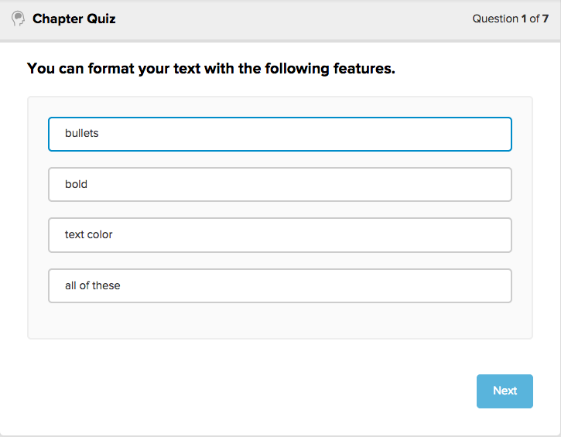
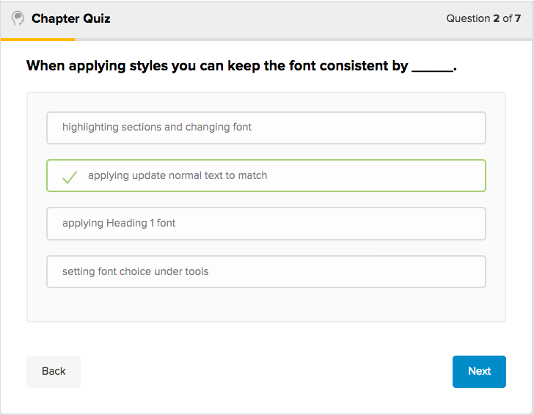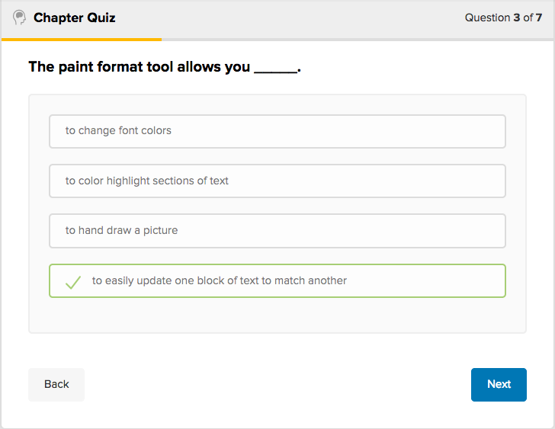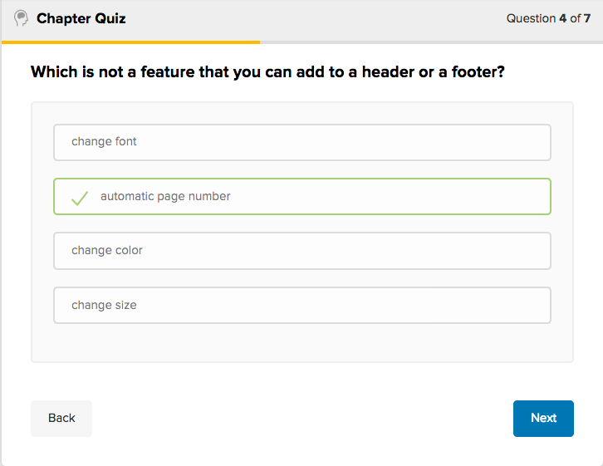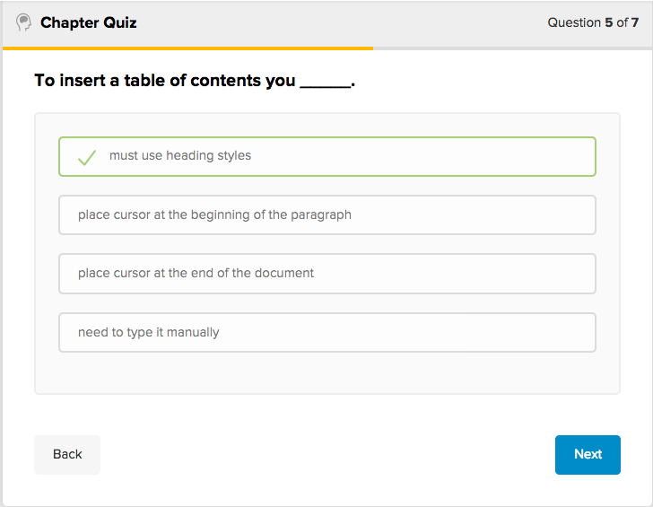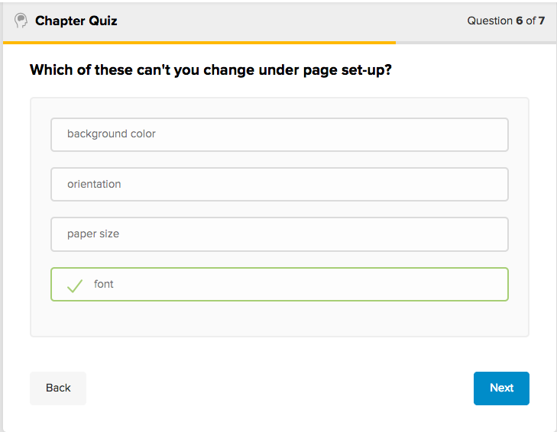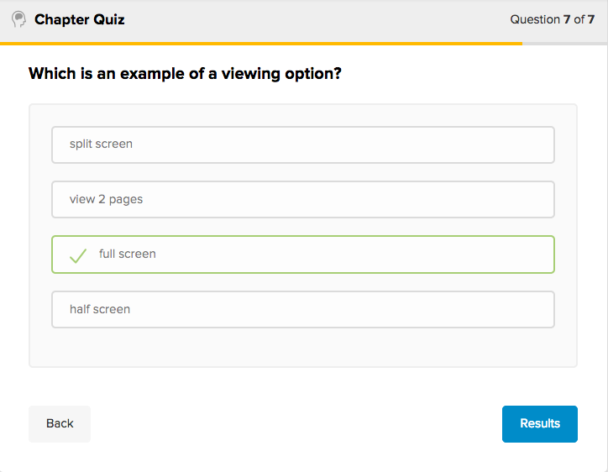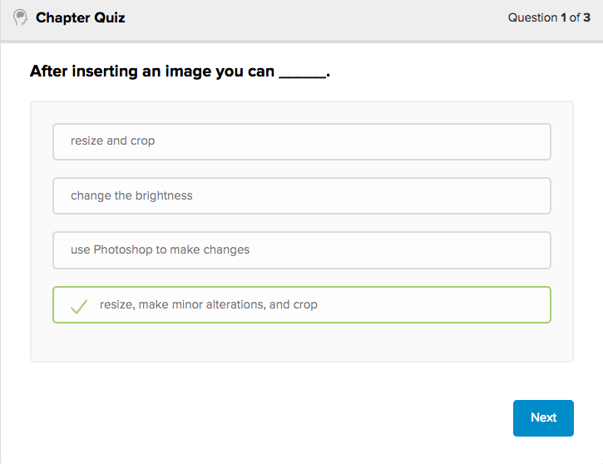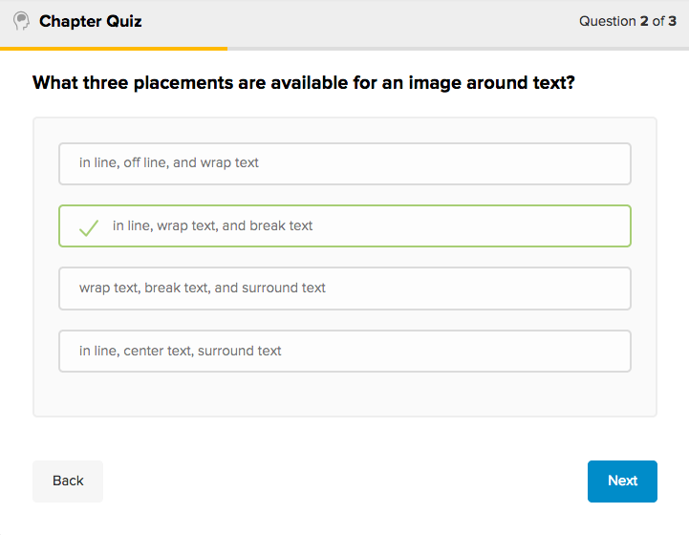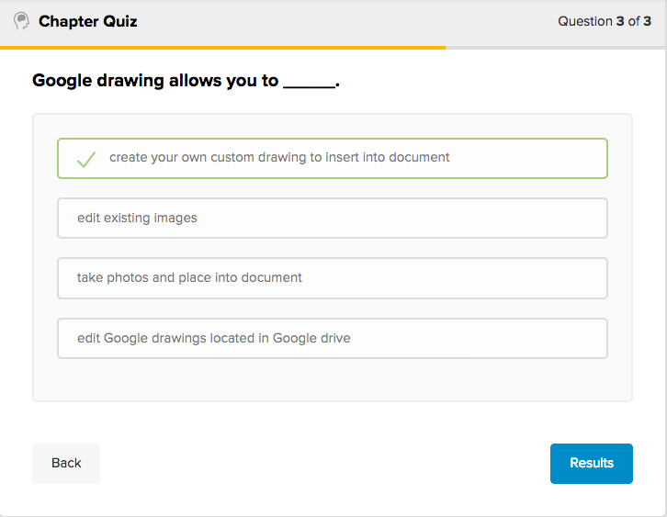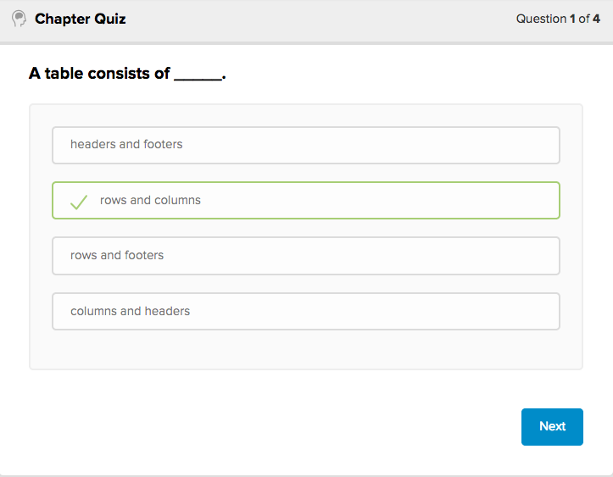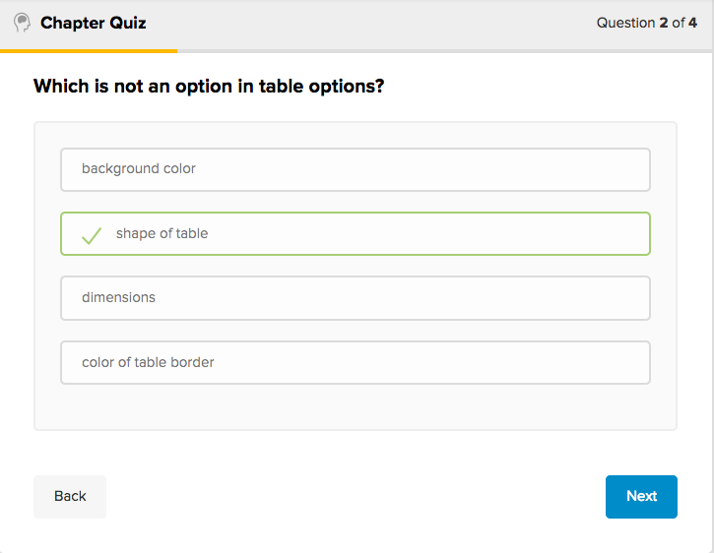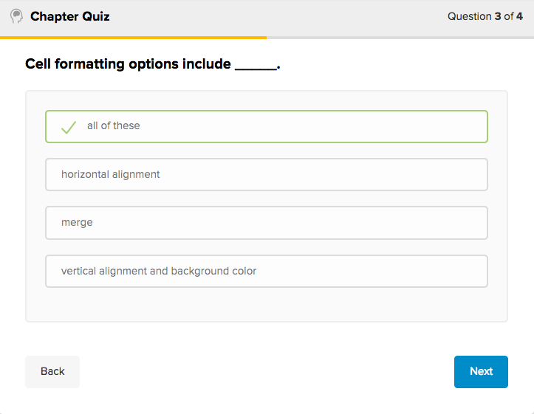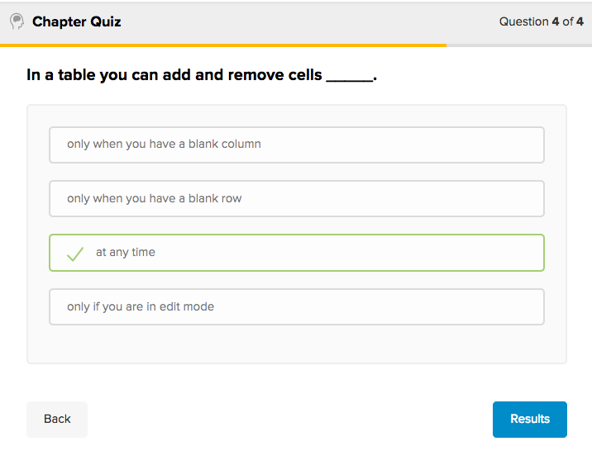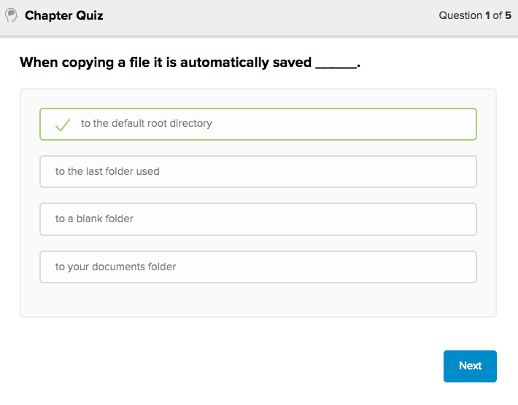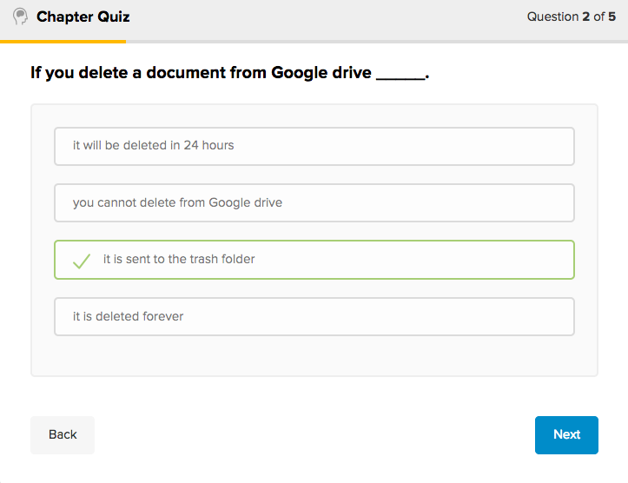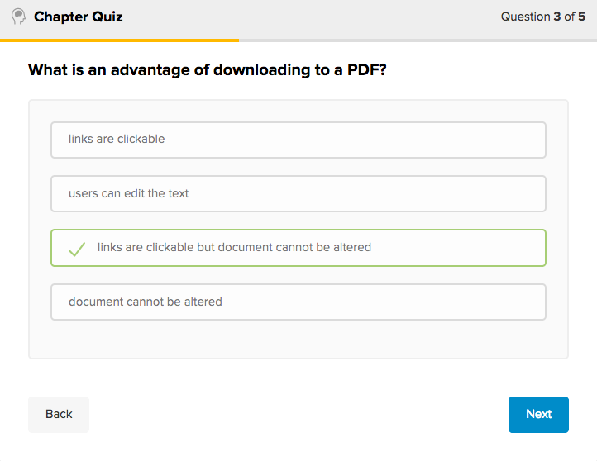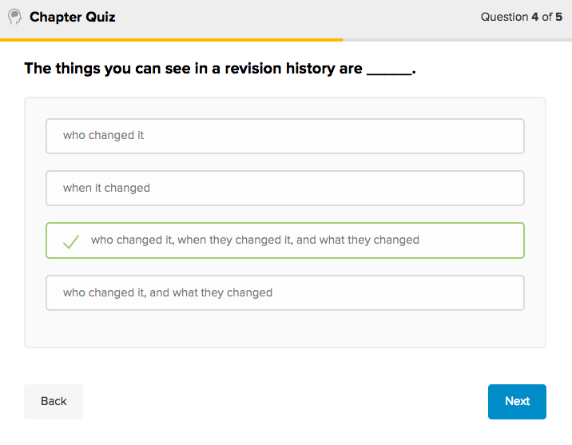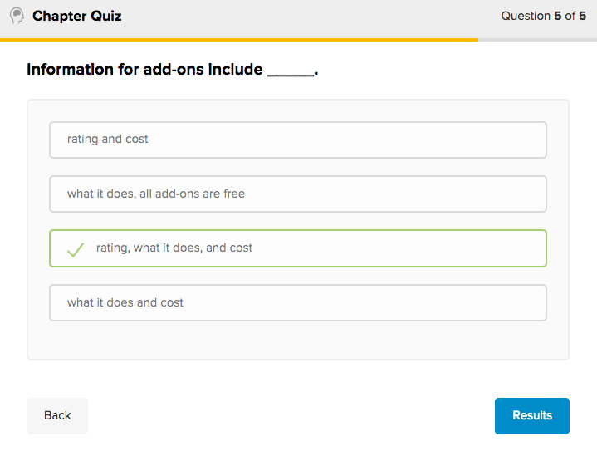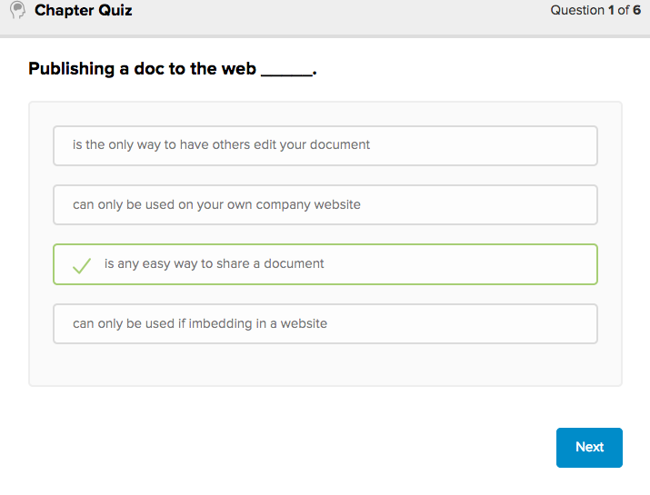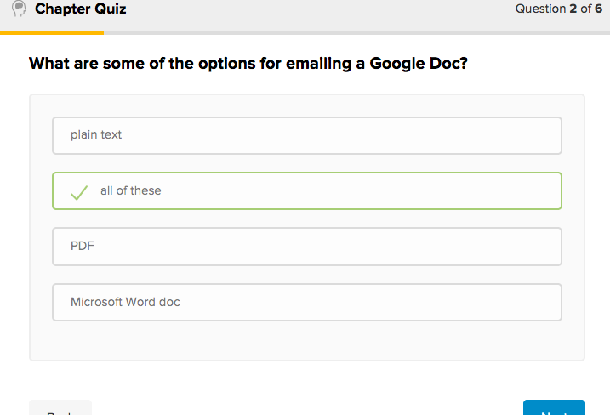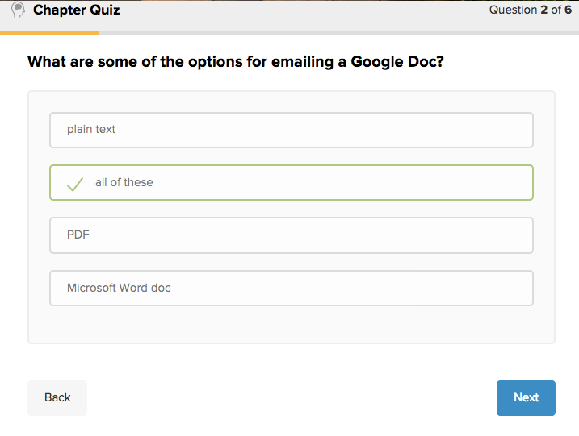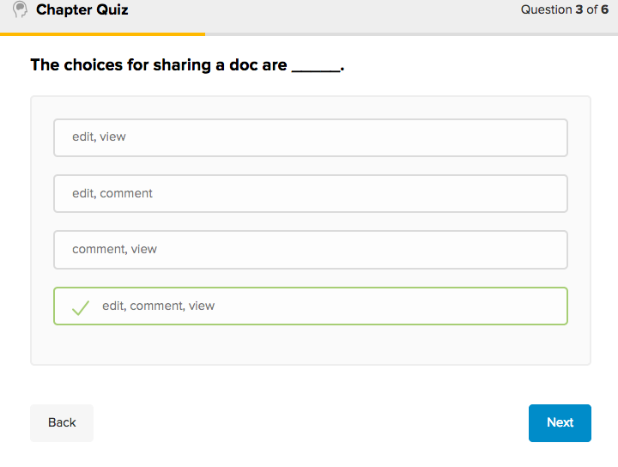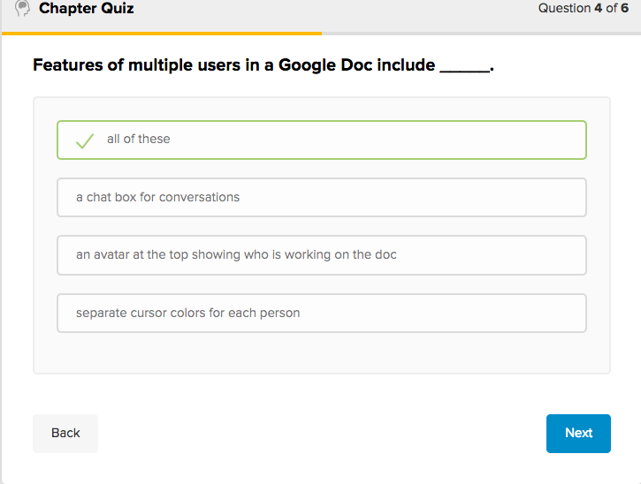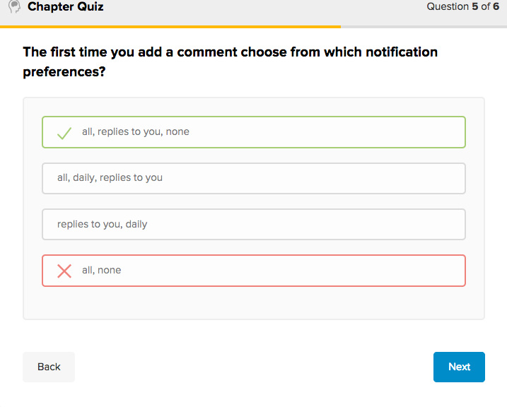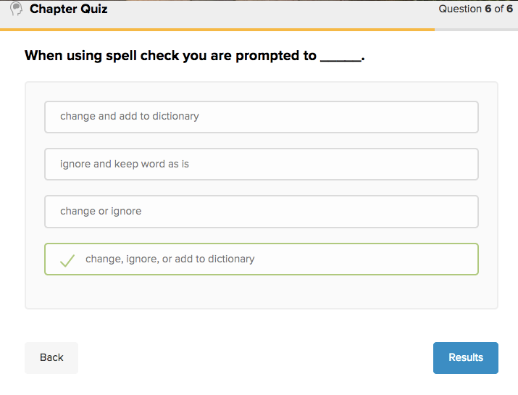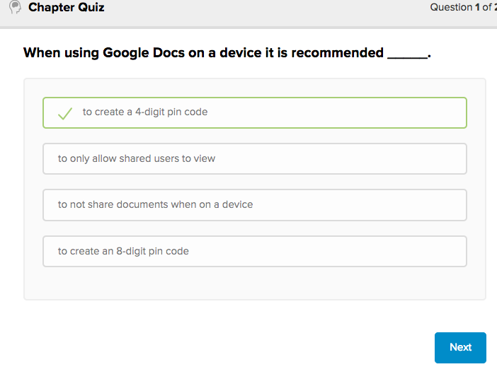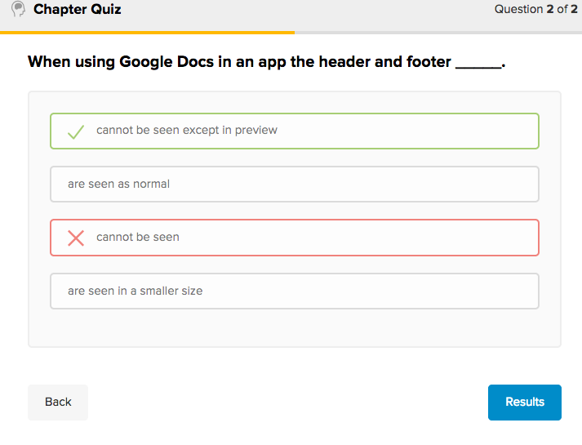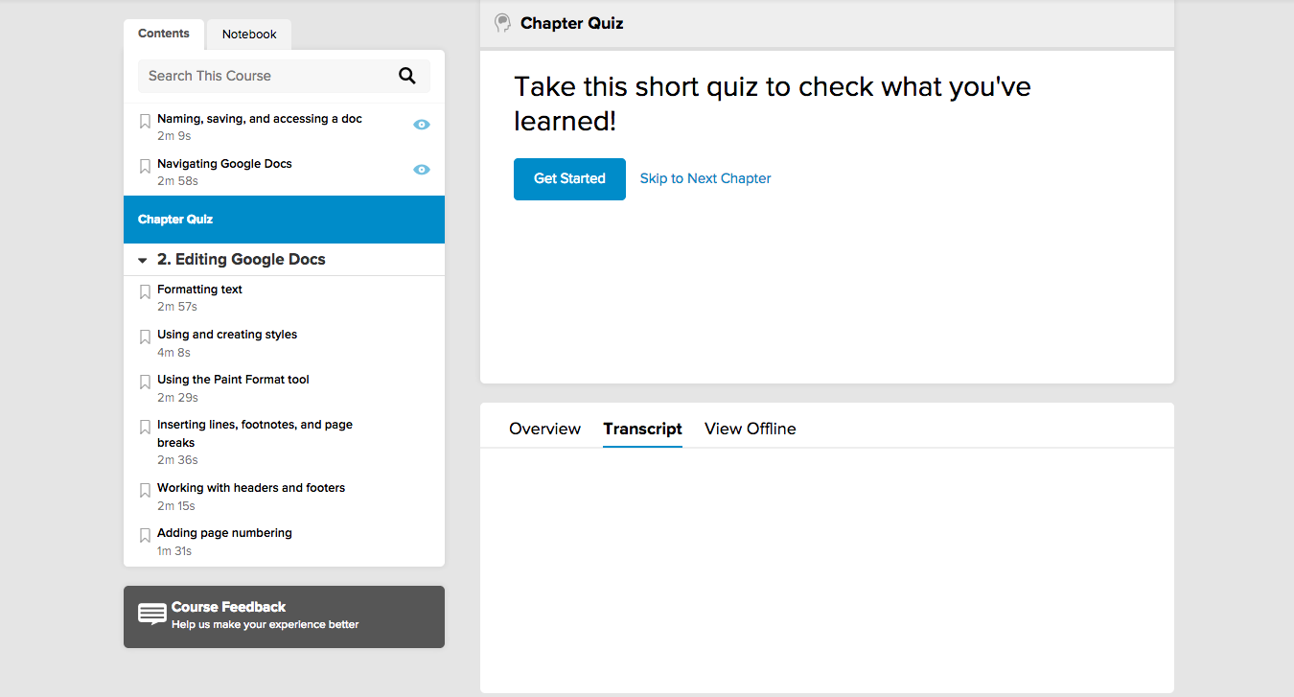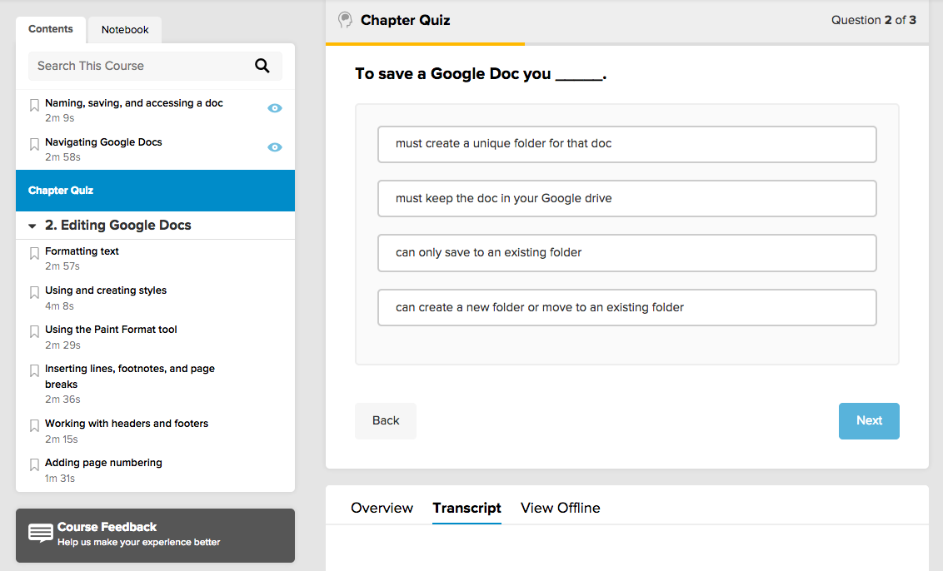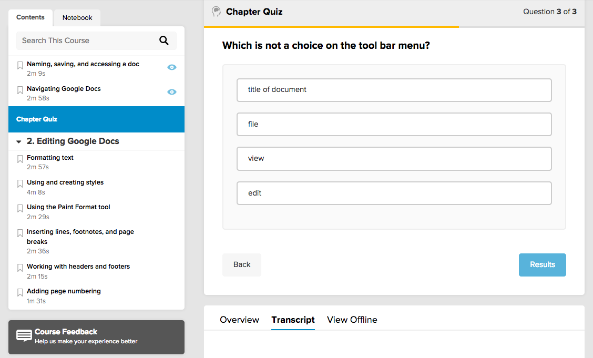

Appendix D: Modified Learning Quizzes with Answer Key
These are screenshots of the modified Learning Quizzes for the current Google Docs Learning Module quizzes developed by the evaluators. As stated by the screenshot, these would occur at the conclusion of every chapter of the learning module. These questions were modified to be more specific in language. The current quiz questions provided by Lynda.com had value and some were utilized in the modified quiz as well.

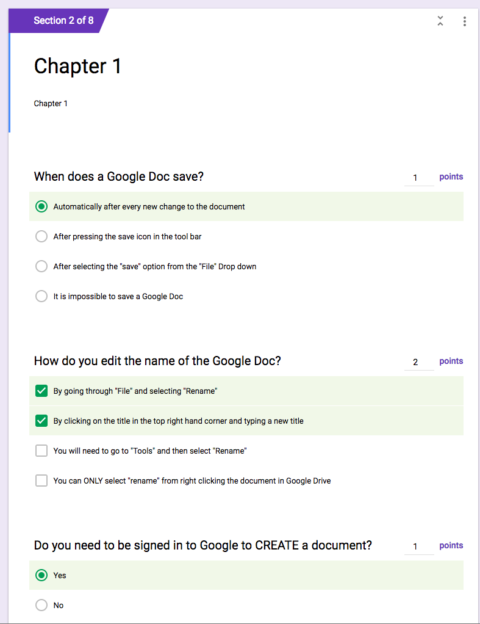

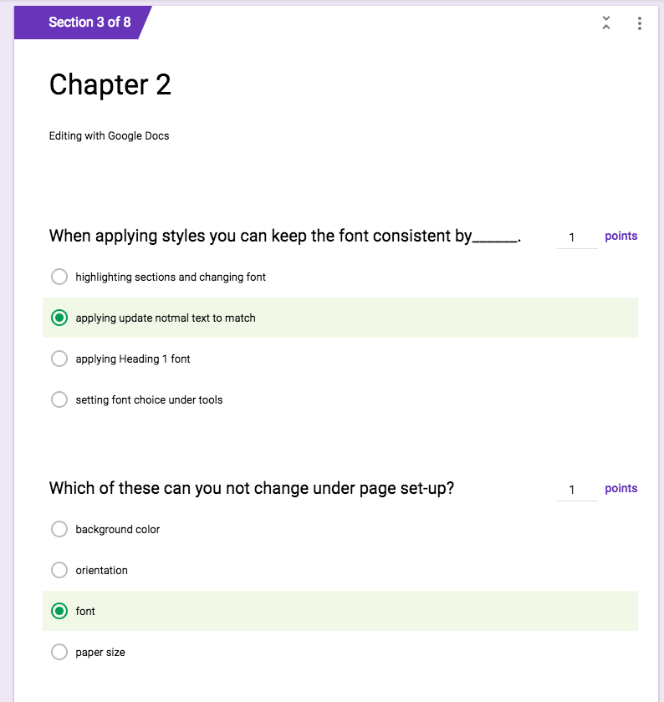
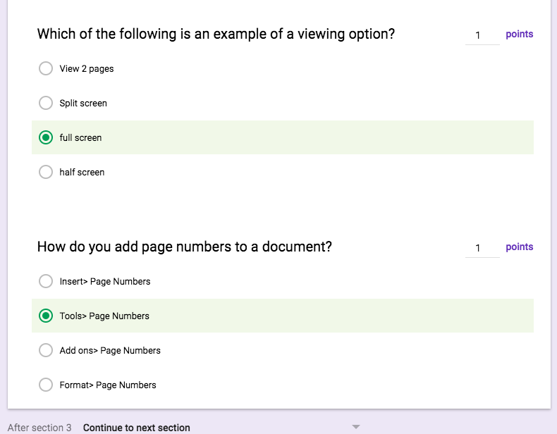

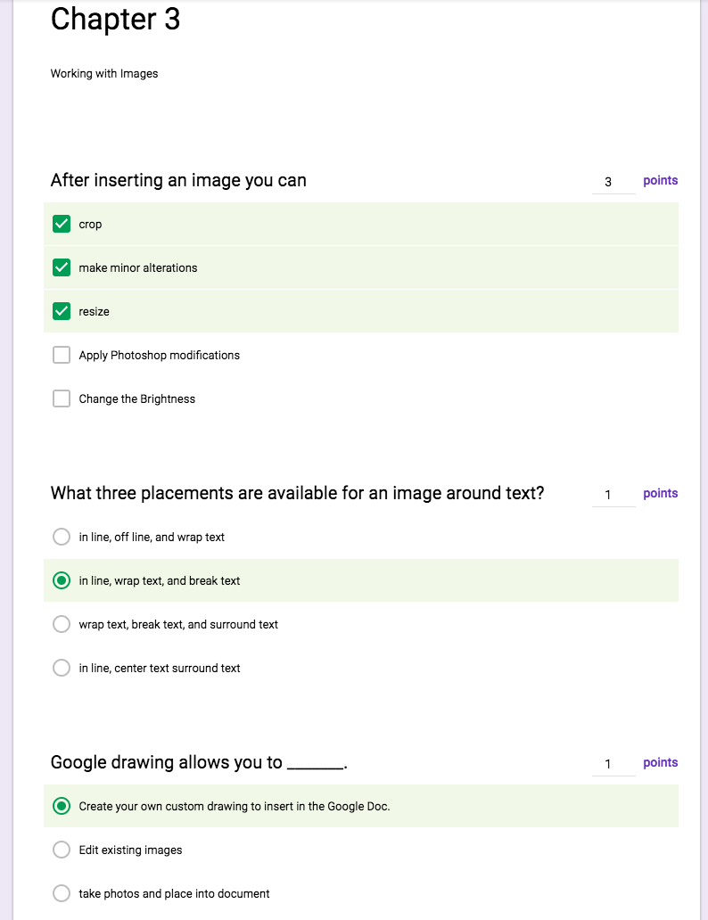

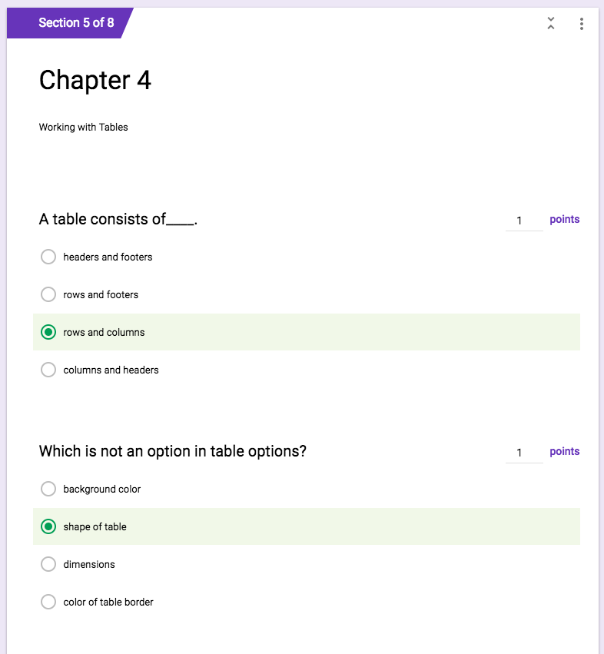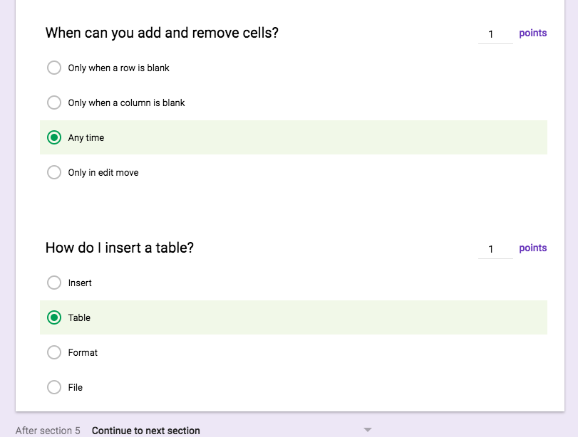
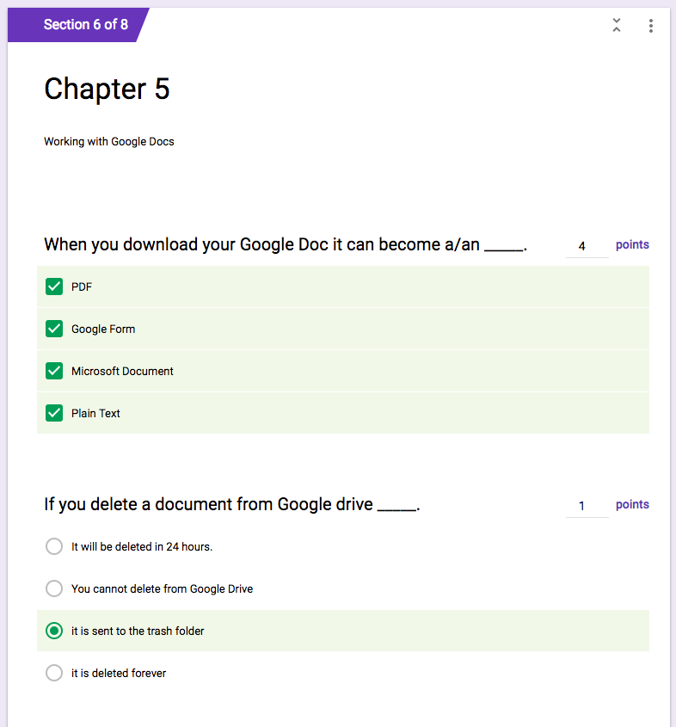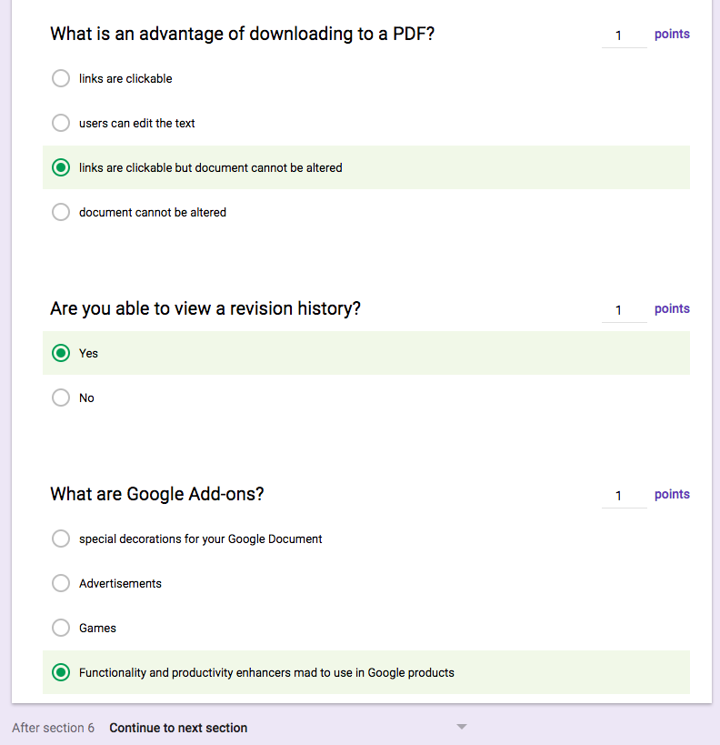

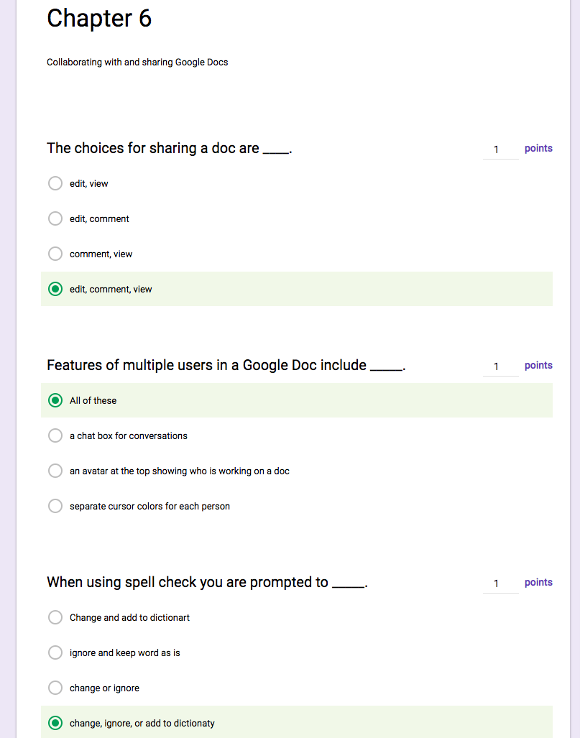

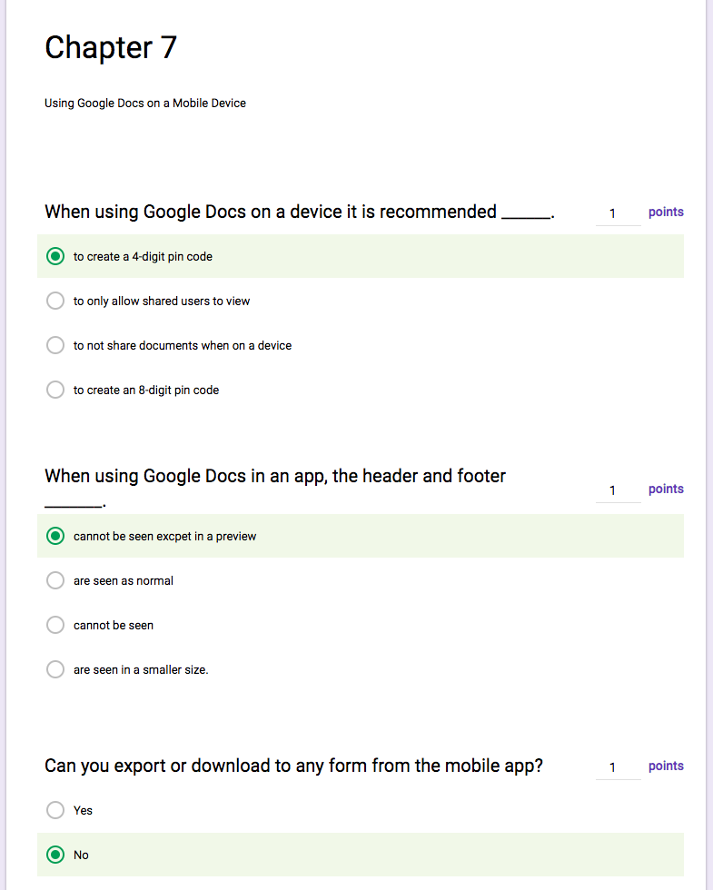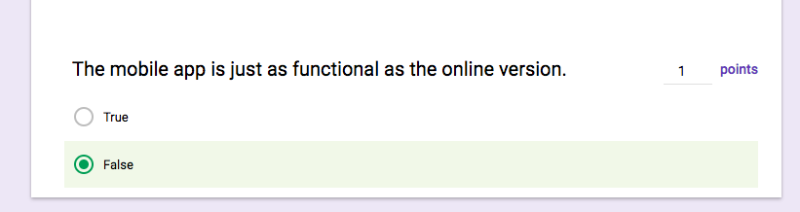

Appendix E: Collection of Data for Level 2

Steps | Requirement
1 | Participants will be complete each chapter of the module and take the Level 2 learning quiz immediately following completion of the chapters
2 | The evaluator will be responsible for using Google Forms to collect the data. Data should be imported.
3 | The evaluator should determine the percentage of participants that completed all portions of the learning module
4 | The evaluator should then find the percentages of correct answers on each question from all the learning quizzes. (26 questions in total).
5 | Utilizing Google Sheets, graphs showing individual questions and their percentages should be formally analyzed and reported. An evaluator's analysis should be included.
6 | The Google Sheet containing the success rates for participation and correct answers should be included with an evaluator’s analysis in the final report to the administrator or learning module author.

