Final Completed Project and Report
EDCI 57300
Alicia M King
Purdue University

STEM Website
All lessons can be found on the website. Kahoot assessment for 4th Grade Ecosystems and evaluation form will be found within this document.
https://icisstem.weebly.com/

Executive Summary
Purpose of the Project
The purpose of this project is to meet the need of designing a STEM curriculum for Indian Creek Intermediate School. This project consists of a new STEM website as well as 9 lessons that are on the subjects of either science or technology. The STEM Classroom was started in the 2017-2018 school year. The principal and current STEM teacher envisioned and desired having a STEM curriculum to use in the classroom as well as a new STEM website for our school. When I approached them about a project idea, this was the first and most emphatic response. This idea would be to create technology enhanced lessons in a face-to face classroom setting. This would be a perfect opportunity for an instructional designer so I gladly wrote up a proposal.
Another specific purpose of this project is to start the official transition of teaching Digital Citizenship through the STEM classroom. There are always many scheduling complications when trying to teach digital citizenship lessons for a week in addition to the regular STEM schedule. Although it is taught in the STEM classroom, the technology integration specialist will be delivering these lessons in the STEM room during the normal STEM schedule. For this reason, we have included in the project, two digital citizenship review lessons that were created for third and fourth graders as well as three brand new fifth-grade digital citizenship lessons created to meet CommonSense.org’s requirements for certification.
How it will be used/ Outcomes
The outcomes of this project will result in a personalized, Indian Creek STEM curriculum that can be used every year starting in the 2018-2019 school year. These lessons will be used in a 1 to 1 setting using Chromebooks. Each lesson will be around 30 minutes long and used in student groups no larger than 30 students. The regular STEM lessons will be led by Jessi Ellis, the STEM teacher. The digital citizenship lessons will be taught by myself, Ali King, the incoming technology integration specialist.
During the evaluation portion of this project, it was expressed by the STEM teacher/supervisor that this will be a growing project and more lessons will be created with similar structure and housed on the website. With this opportunity we hope to add more engineering and math lessons that had to be skipped due to the more immediate need of new digital citizenship lessons that will be presented in the fall. I’m excited to continue working on this project and with this supervisor. I’m looking forward to expanding this project in the upcoming months.
Processes Used
The ADDIE model was used for this project. Analysis was the first and easiest step. I have been a third-grade teacher for 5 years and spent one year with high ability 4th and 5th graders. My supervisor currently teaches every student in the building through the STEM program. Using my supervisor's expertise and my knowledge of intermediate students we were able to paint a great picture of what the students needed and what the program needed. This was completed prior to the project officially beginning. We determined the students needed face-to-face instruction with an integration of common and familiar technology tools to enhance the lesson.
There were not many design limitations for this project. This was very beneficial when it came time to develop the actual lessons. Topics, design features, content and corresponding activities were all left to the instructional designer. The five digital citizenship lessons had design plans that were used from CommonSense.org. Rough notes and outlines were written up during meetings with my subject matter experts for the other four lessons. This project was not made using a formal design plan.
All lessons had to be developed with Google tools (Slides, Forms and Docs), due to most of the lessons being presented or used on a Google Chromebook. The development stage included creating a presenation, lesson plan and assessment or activity or each lesson topic. The goal was to create simple, technology driven lessons for students. The lesson development took longer than anticipated and often were the first pieces to be extended into later weeks. However, due to changes we were able to remove two lessons from the originally proposed plan that helped us make up development time.
Full implementation will not take place until August and September. However, we were able to have pilot tests. Revisions were made in a timely fashion. Final evaluations and data was gathered to make these revisions using a Google Form (Appendix A). This form was made up of open ended questions, letting the evaluator be as specific as possible on thoughts and suggestions for the lesson. This form was sent out to the Pilot Group that consisted of 6 individuals ranging from 4th grade student to Middle school teachers. The data found (Appendix B) from the evaluation included minor changes such as errors or suggestions. Many of the suggestions were not added to the lessons due to time constraints, however, could serve as great additional resources following the lessons completion.
The website was designed using Weebly. This was a platform the STEM teacher was familiar with and met the needs of our project. Displays were sketched up before the project was started. Its primary use is to house resources, pictures, news updates and house lessons that were developed during this project. Creating the skeleton and color schemes for the website was one of the first things I completed for this lesson. This was done first so that artifacts could be uploaded as necessary when it was completed. This also gave my supervisor a way to check on completed work.

The Key Instructional Design model
I used the ADDIE model to complete this project. I enjoy using this model, because it is simple and straightforward when creating the lessons. I began with Analysis of the learners and content, I then began to Design and Develop the lesson plans, presentations and assessments. The final steps included implementation and evaluation.
Using a straightforward model seemed to be very helpful when creating several short lessons. I was able to use the whole model quite efficiently. I would say analysis of learner and content were completed as the model demands. Development and design were two stages I spent the most time on. Implementation was a difficult step to complete. My lessons are intended for groups of about 20 students in a 1 to 1 Chromebook classroom setting. Due to the project’s completion in the summer months, I did not have access to this kind of setting. Instead I implemented my lesson within a pilot group that completed the lessons from their own homes and offices. While this does not represent true implementation, I did receive helpful feedback to evaluate and revise my lessons, so they will be ready to fully implement in the fall of 2018.

Reflection Narrative
What was Learned
I learned the importance of communication among team members. I had a successful project because of the level of communication among myself, my supervisor and my subject matter expert. This constant and honest stream of communication was helpful and essential to this project. Creating ideas, changing content and completing revisions were flawlessly done by keeping a constant stream of communication open. This is something that I will continue to focus on in the future.
Another thing that was very helpful to understanding my role as an instructional designer, is the ability to make sure that lessons include everything an instructor might need. In the past when creating a lesson, I would record the basics in some way that I knew the materials and the all of the pieces that would go with the lesson to make it successful. However, when creating lessons for someone else to use, I found myself being very specific and making sure that all resources could be found when needed. The lessons in this project have some hands-on-activities as requested by the subject matter experts. Making sure that there is a definite list of supplies that the teacher will need is very crucial. I also made sure to include assessment links or video links in several places to make sure the teachers who will be delivering the content will be prepared at all times. This was a good habit that this project helped me develop. As an instructional designer and incoming technology integration specialist, I will have many opportunities to create lessons for other individuals to use in the classroom. I will continue to remain thorough when preparing lessons.
The last major concept that I have discovered involves creating lessons with technology enhancements and knowing your intended educator. I had to be sure to not include an assessment on a technology tool that the teacher may not be familiar with. For example, I included Kahoot (Appendix C) in one of my lessons. Using a similar tool such as Socrative might complicate things due to lack of knowledge of how to use the tool. This would not help the educator and might even hinder the lesson if they were forced to work with an unfamiliar tool. As an instructional designer, I would argue that content and learner analysis are important, however, user analysis is just as important. I know that the teacher intended to teach that lesson is familiar with Kahoot and will be able to use it seamlessly in her lessons.
Key Challenges
My biggest challenges were time issues. Although the Gantt chart was set up to be very ideal and generous on time, the ending of the academic school year and all extra activities as well as switching jobs and rooms, took a toll on my normal schedule for my LDT studies. I was able to reorganize my time commitments once the school year ended, but I was consistently a lesson behind or two. It was a series of inconvenient events and schedules layered on top of each other. I understand that this is part of life and cannot be helped, however it was a major challenge I ran into. I overcame this challenge by simply being mindful of every free opportunity.
Changing the design plan for the 5th grade digital citizenship lessons the week I was supposed to work on them also was a challenge I was not expecting. I sat down with the outgoing technology integration specialist who also acted as one of my subject matter experts and we took a look at the requirements on the Common-Sense website and realized that we had over planned. They changed their requirements on number of lessons and hours that need to be taught. I decided to change my plan so that way I could catch up on time and so I would not be creating lessons that would not be used.
Also making sure that I was meeting copyright laws also was something I had to keep reminding myself. I used Slides Carnival for the design of my presentations. These are free to use. I made sure to leave the credits at the end of every presentation. I also used a website called Unsplash that lets users search for free pictures to use. Other pictures were personal, or screenshots taken with my computer. However, every other image obtained otherwise was licensed free to use or credit was given to the original image. Copyright laws are to be respected and this project was no exception. I want to set an example for the teachers and students who will be seeing these lessons that at all times you must be a good and respectful digital citizenship.
What I would Change
What I would change about the project if I had to start over would be to make an entire unit on one topic. Completing lessons on nine different topics was a challenge. I had to keep working with content that was sometimes vastly different. It might have been more beneficial to make a thorough unit on one topic. This unit could have been in depth on a STEM topic and it could have allowed for me to work in some project-based learning if I knew the lesson could be taught over several days. I think that I would have been better able to make a stronger “STEM Connection” in my lessons. I like to build off of previously learned concepts, and only two of these topics allow me to do that: the digital citizenship review lessons for third and fourth grade.
However, my supervisor likes how the end product came out. She has ways to build upon what I have laid for her. She is excited about the ability to have a strong structured introduction lesson for some of her science topics. Moving forward as I create more lessons for her and the STEM Classroom, I plan to create whole units instead, unless I am asked specifically to create individual standalone lessons.
Another thing I would change is to have a better implementation process. I am currently working on this in the summertime. I do not have access to the ideal audience and learning setting. I instead had to focus on help from subject matter experts, teachers and students. Although, I was given great feedback, I do not feel that I completed the implementation stage as intended and therefore do not have accurate and exact results on the lessons’ delivery. If I were to start over, I would make sure that I had a proper setting and audience to implement the lesson as intended.

Improvement on Instructional Design Skills
I had to work with a team to develop these lessons. Although I have been a part of many teams in the past, working with a group of people to create lessons that I may not teach myself has been a new concept for me. For the first time in my career I had to refer and communicate with subject matter experts and supervisors. I couldn’t rely on myself to make decisions. As a classroom teacher, I was used to making most if not all the decisions based on how my instruction would look and feel. I’m glad that I had an opportunity to create instruction that was not all mine. I believe this gave me an accurate exposure to work as a true instructional design.
I also felt that my development skills have also improved. I was more conscious of using consistent font styles, size and colors. I felt that I was able to create design structures for my lessons, lesson plans and website that were beneficial. This helped me present the various content pieces in organized and predictable ways for the students and teachers using the lessons
I believe my ability to implement and evaluate instructional content can be improved. I believe that on my own, I did not establish a great implementation plan. I hope to improve this in the future. It was hard to find a proper audience to properly implement my project. As an instructional designer, to properly implement any lesson or training, I know I will need to use the lesson or training as intended to receive an accurate picture of what it will look like. In the future I hope to improve these skills and find ways to better use the implementation and evaluation stages of the ADDIE process. I also hope in the future to have the chance to sit down and present findings properly with my team to make sure that we are delivering quality content to our students.
Appendices

Appendix A
Evaluation/Feedback Form

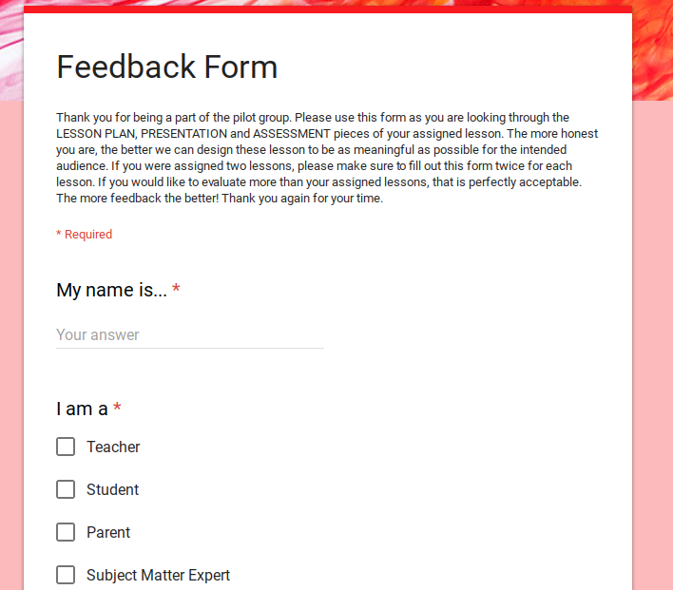
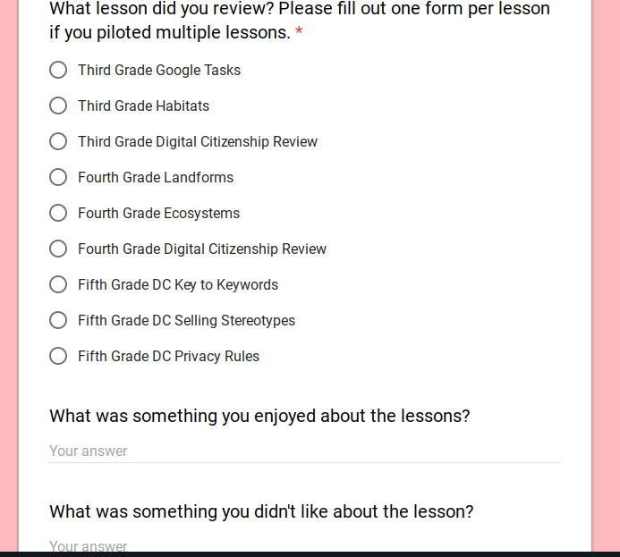

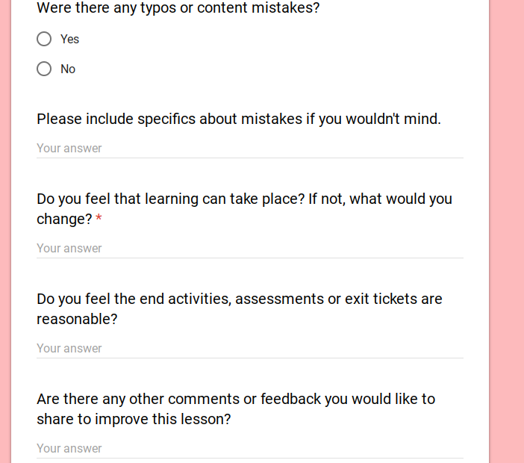

Appendix B
Feedback Data
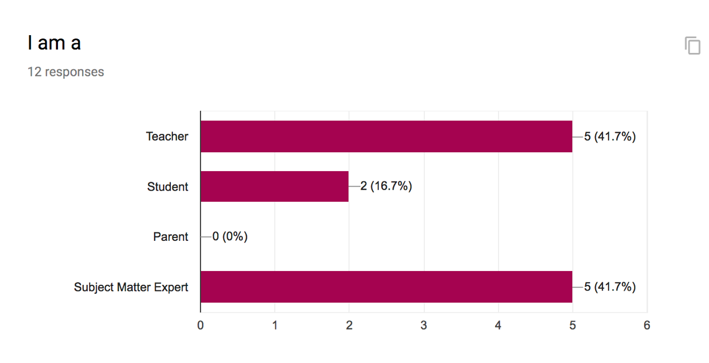
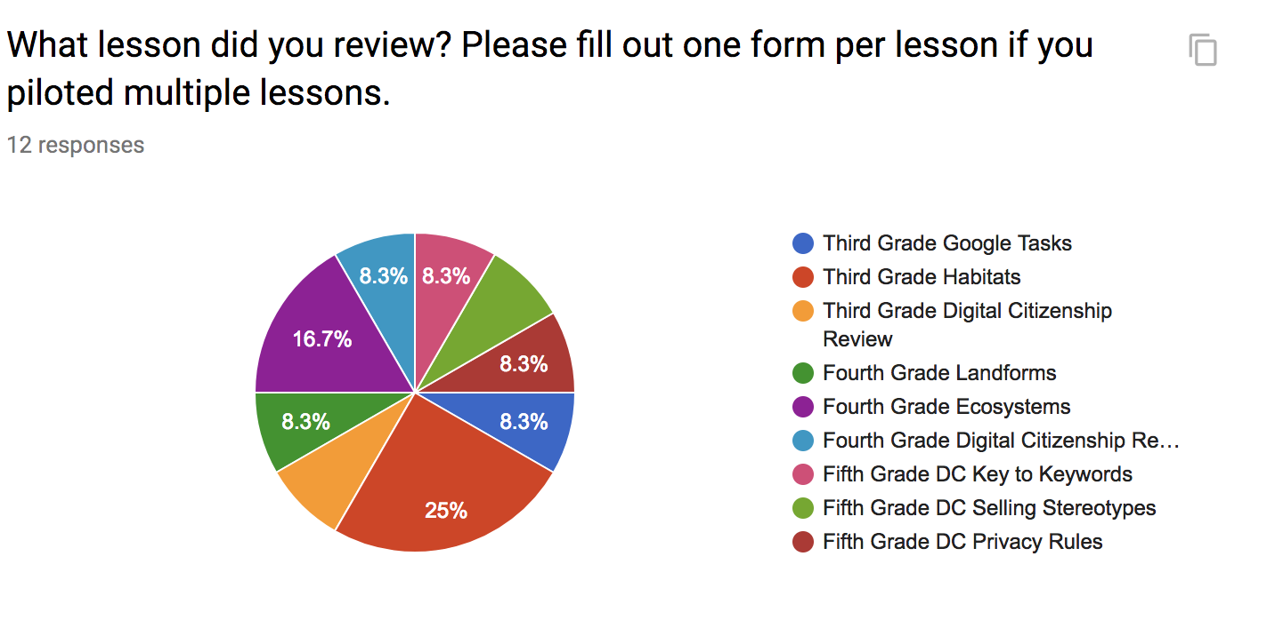
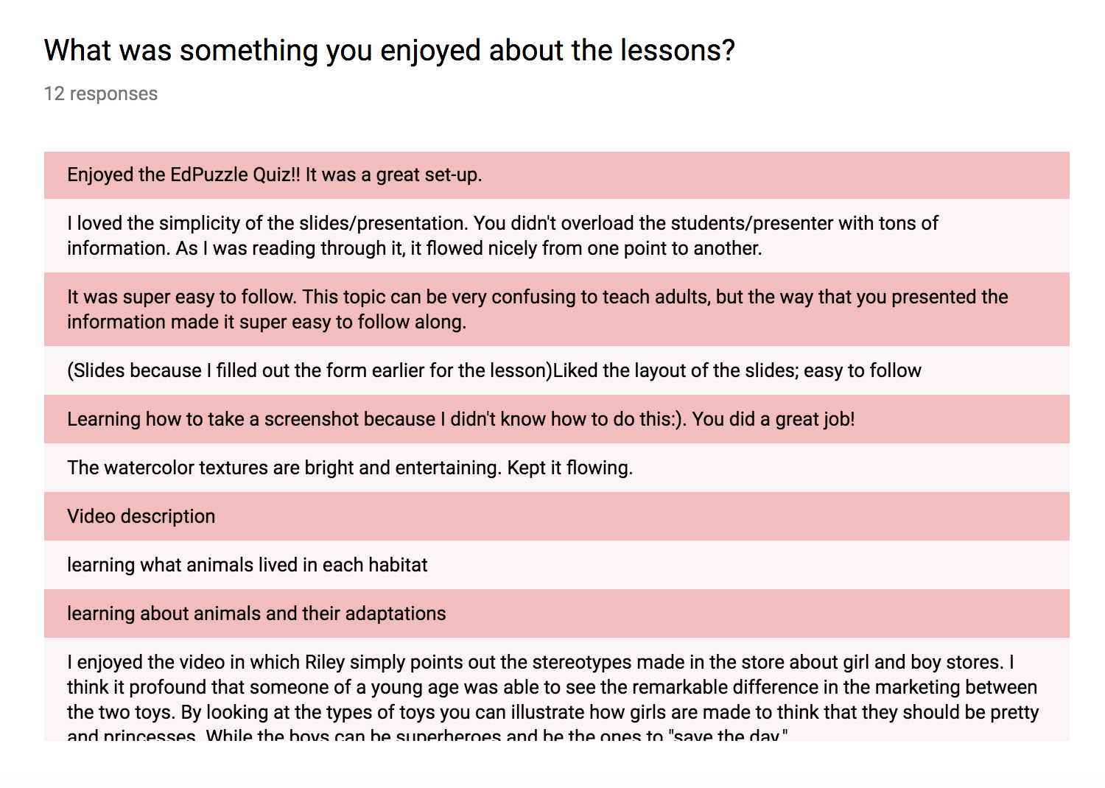
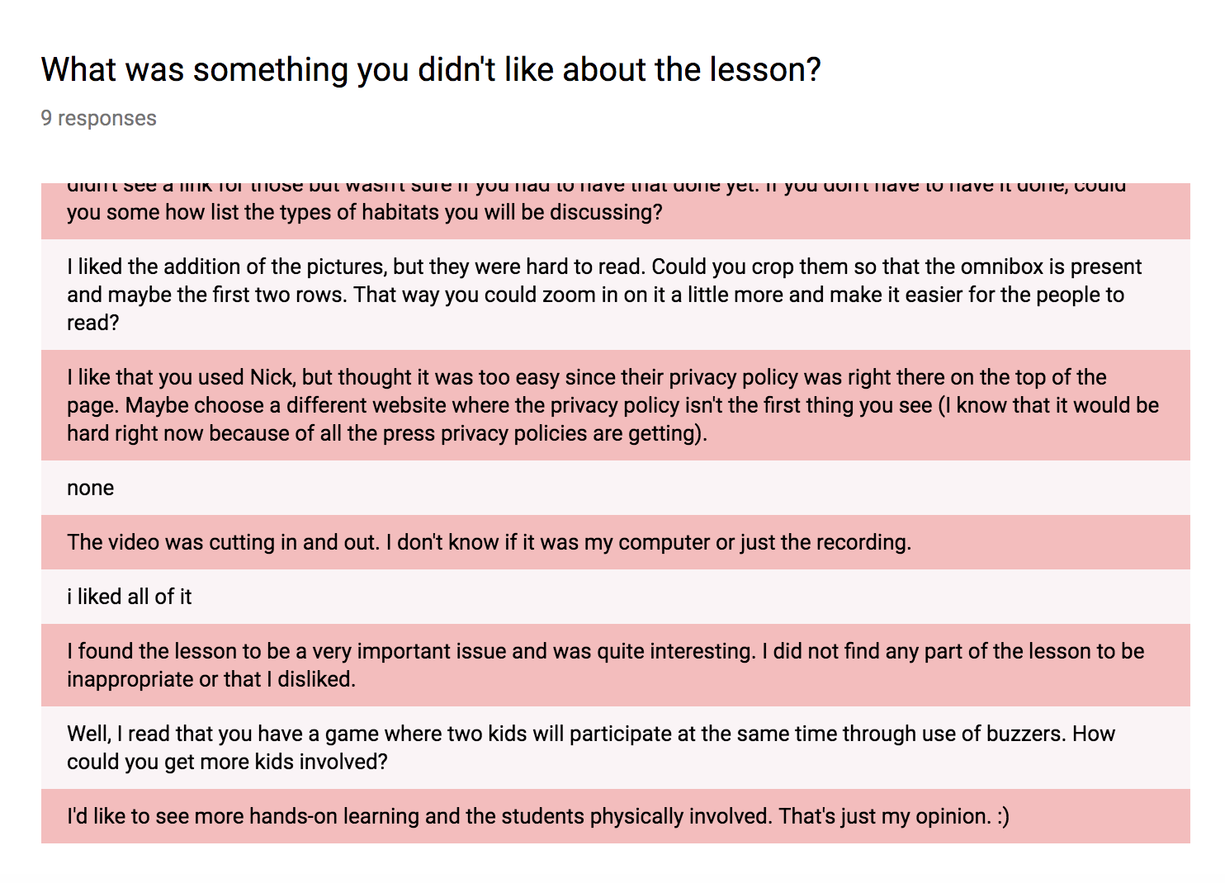
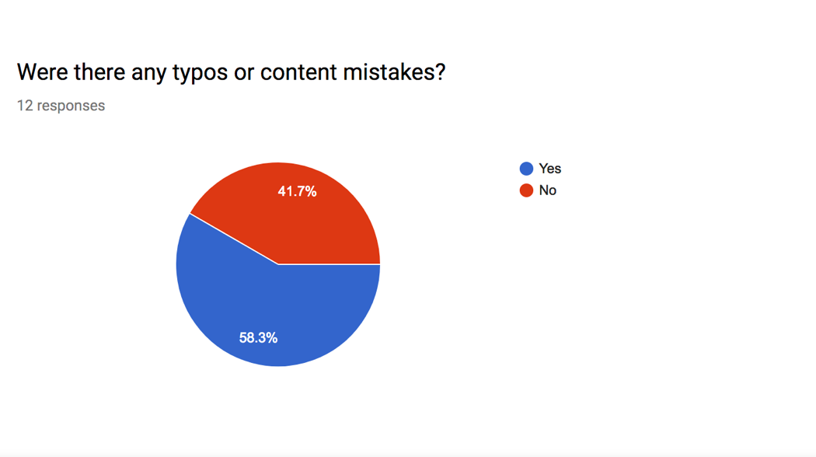
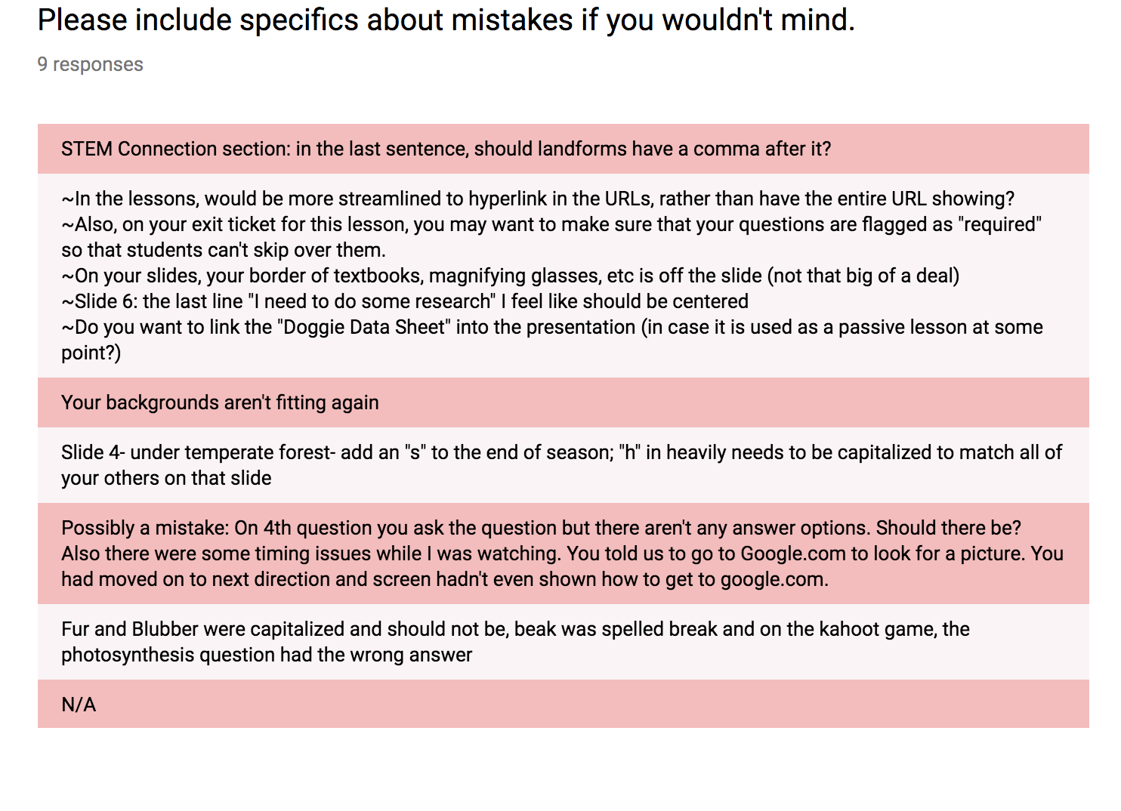
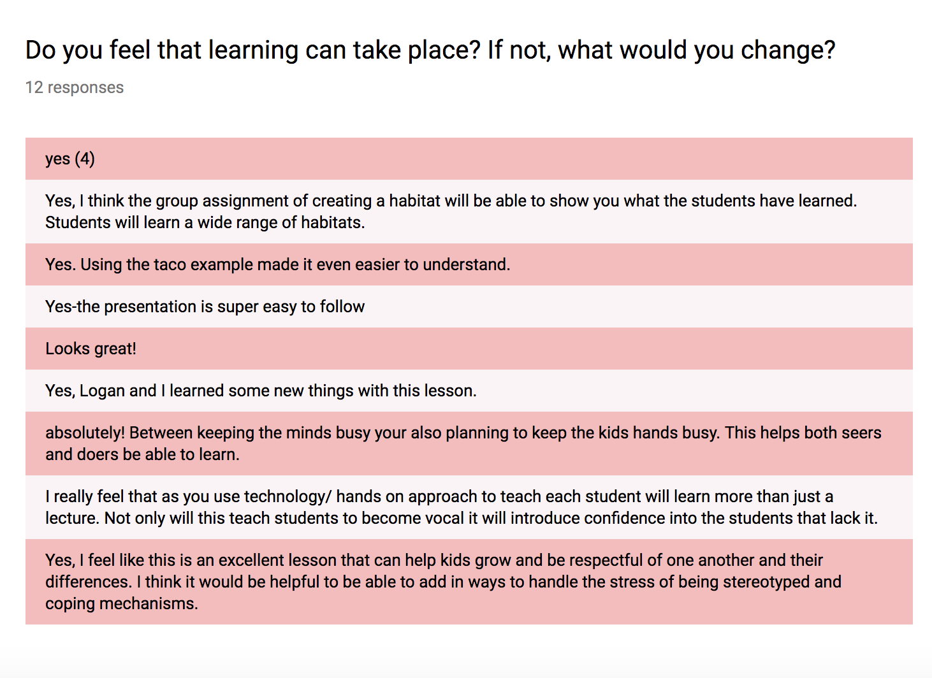
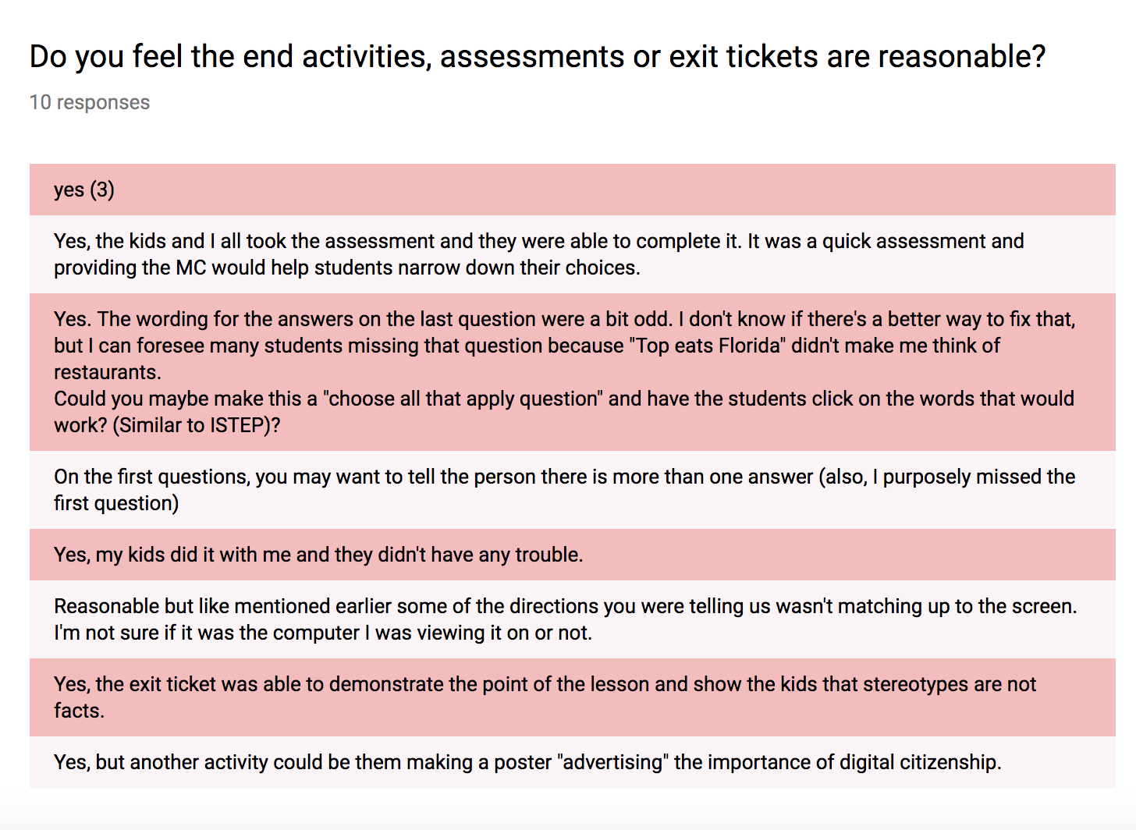
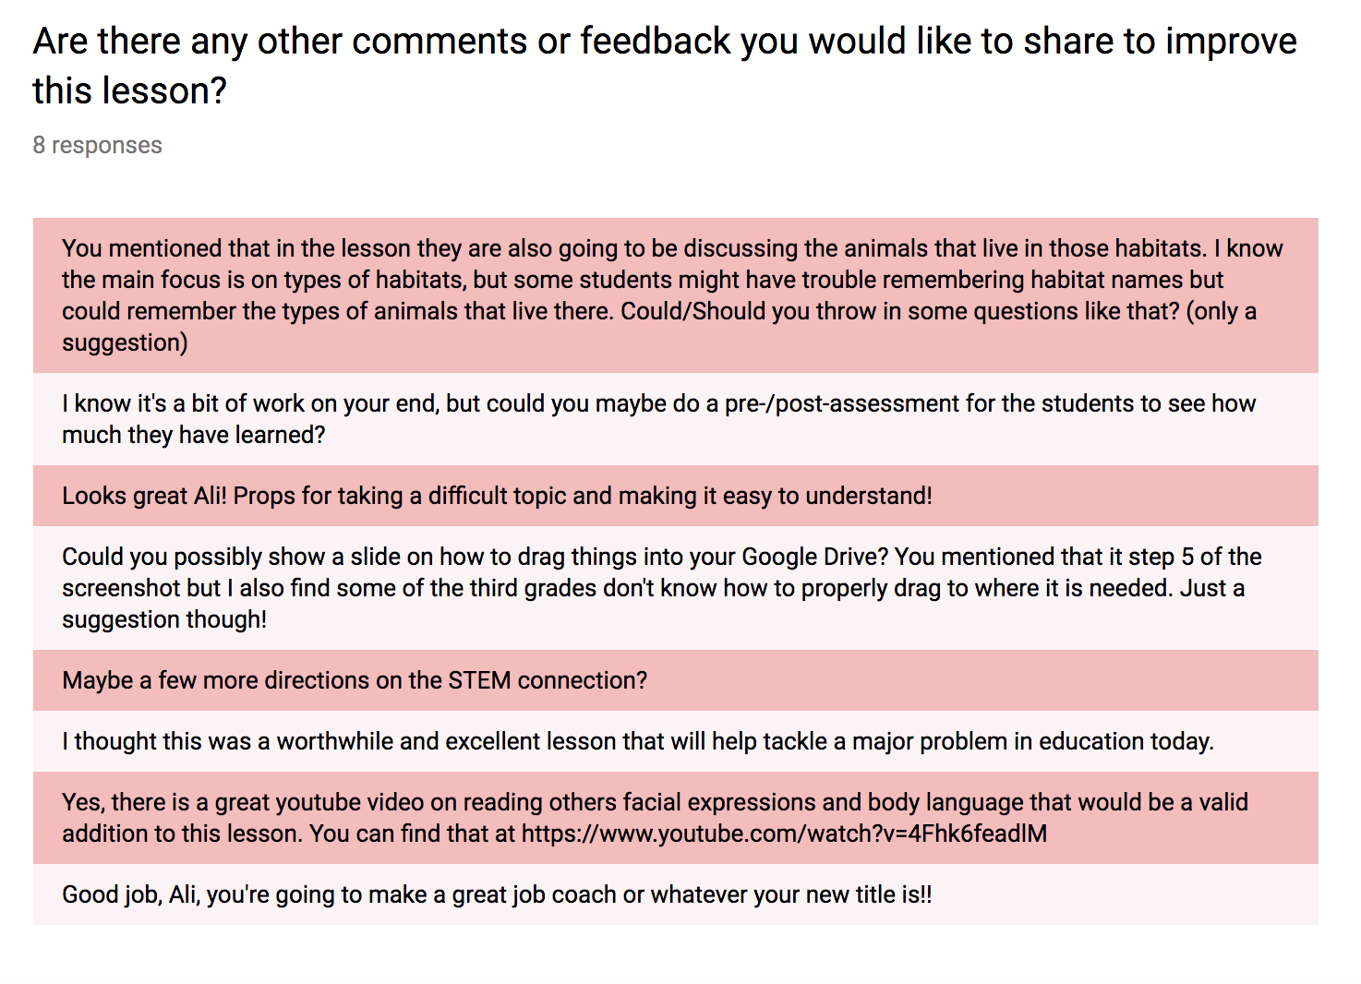
Appendix C
Kahoot Assessment

