Developing eLearning with ADDIE
EDCI 56900: Assignment #2: Design Phase
Alicia M. King
Purdue University

Table of Contents
Part 1: Project Background: 3
Part 2: Front End Analysis: 3
Part 3: Learning Objectives 6
Part 4: Site or Directory Map 7
Part 5: Wireframe 8
Part 6: All Instructional Content 8
Additional Instructional Content: 13
Part 7: Self-Evaluation 14
References: 20
Appendix A: 21
Appendix B: 21
Appendix C: 22
Appendix D: 22
Appendix E: 36
Appendix F: 37
Appendix G: 38
Appendix H: 39
Appendix I: 40
Appendix J: 41
Appendix K: 42
Course Rubric 43

Part 1: Project Background:

Subject
I propose to create an eLearning module focusing on how to write a summary. This module will focus on creating a written piece that will be used to fulfill a requirement for a certain project. Specifically, for this module, we want the students to write a small summary about a selected figure. This is not intended to be a full research report.
The steps will include first selecting a figure to study. Once this has been finalized, the students will need to proceed through the module and piece together required information such as basic facts about their background, why they are well known and other facts that interest the author about their subject.

Learning Context
This module will be designed for third grade students. Every year the third graders at Indian Creek Intermediate School partake in a “Wax Museum” project. They are to select a famous or historical figure to research and write a small summary about. The purpose of this project is to provide detailed instruction for students fulfilling the writing portion of this project.
Following the module, the students will gather a costume to dress as their selected figure and then prepare to go on display in the school’s main hallway with their summary available to be read by “museum-goers”. Students may also read or memorize their summary instead of displaying their writing depending on their public speaking skills, ability or accommodations.
As discussed in the “Target Learner Analysis” section following this portion, students in my classroom vary greatly in ability and processing skills. This project will allow for students to complete the assignment in their own pace. With resources and activities available online within the module, the teacher and special education assistant will be able to act like coaches and not have the pressure of conducting a solely teacher paced lesson.

Project Scope
I will have roughly 5-6 weeks to complete this module in its entirety. This will include creating the material, uploading it to my preferred platform, creating all associated tools as well as implementing and evaluating successfully.
I am very fortunate to be an instructional designer in the making as well as the subject matter expert. I will also be the one delivering the content during implementation. This will be very beneficial in this specific project. I believe this project is feasible.
I have attached a Gantt Chart as “Appendix A” to show further detail. I have given myself about two weeks for the design and outline of the platform to be completed. However, I have given myself a little over three weeks to gather all the necessary content for all activities. This will be the most time consuming of the process. I have given myself about two weeks to finalize details on the platform and within the content. All pieces will be ready for a formative assessment by the end of Week 6 of this course.

Part 2: Front End Analysis:

Target Learner Analysis
My project has been designed for third grade students and will be specifically implemented in a class of 22 students. These students are current 8-9 year olds that I work with every day as their classroom teacher. My students include a handful of inclusion students that currently have IEP’s. I have a full-time special education assistant to help differentiate their instruction. Along with many grade level students, I also have two students that register at a 6th grade reading level on district-wide assessments. This information has been obtained through Lexile testing, district-wide testing, observations and school records. I have worked with these students adapting, differentiating and personalizing content to their abilities since August of 2017.
Prior to this module, students will need to have completed lessons on research and basic paragraph structure. Ongoing lessons such as proper sentence structure and grammar lessons will also be beneficial to the success of this module. This module will present a style of writing and not the mechanics of basic writing itself. The students like to be hands on and enjoy using their Chromebooks. We have had success completing E-learning days at home without direct assistance from a teacher. Therefore, I decided to pursue an online learning module with this group. Writing is something my students have struggled with in the past. I’m hoping that taking time to gather and construct specific helpful resources will be beneficial to my students.

Learning Environment/ Proposed Delivery Method
The module will be hosted on a website building platform. I have chosen Weebly due to my familiarity with its functions. This also gives me the option to link and embed various types of media to the pages. I will stick to videos hosted from YouTube as well as other Google Products. This will give me various options and tools to work with for my activities, and it will allow my students to work with online tools that are familiar to them.
The goal is to have my students access Google Classroom as normal. They will then have a link to the Weebly site posted for them to access. The Weebly site will be broken down into pages that are specific to each topic or learning objective. They will complete the activities in order. At the bottom of each page will be a button to move on to the next page. Although I will not know when they complete a topic and move to the next, I plan to monitor the submissions to Google Classroom to track activity.

Intended Instruction
My module will be more aligned to an instructor-guided course. Most students will have the chance to work at their own pace. However, I plan to implement my module within my own brick and mortar classroom. Horton (2012) said a physical-classroom setting is ideal for learners who need external motivation and need direct validation. I think this statement aligns perfectly with my decision. My school is 1-1 Chromebooks which will be the key factor to making this module successful.
The students will need a few entry skills before completing the course. They need to be well versed on how to navigate Google Classroom and most GAFE (Google Apps for Education) products. Academically, the students need to be have at least one lesson on how to conduct proper research using Google as a search engine. Students will also need to write proper sentences. Sentence structure will not be taught in this module. Students will also need to be exposed to paragraph writing, however, this does not need to be a well-assessed skill. Spiraled instruction on grammar and punctuation will also be helpful in completing this module.
There will be basic instruction given to the students prior to them beginning the module. This will include my expectations of their behavior as well as a complete overview of our “Wax Museum Project”. I will clarify with my students how they are to ask questions using the module and resources available to them. However, the module will all be delivered online and accessible by our LMS, Google Classroom. All other specific instructions regarding where to turn in activities and how to progress will be given through their LMS. There will not be any whole class instruction once the module has started. I am also interested in incorporating Horton’s (2012) ideas of coaching as well. For my higher learners to fully simulate a true eLearning module, I will have the students communicate through our LMS to ask questions to myself. However, my more dependent learners, will also benefit greatly from having a coach, but in a physical form.
I have planned activities to be helpful and provide variety to my students’ learning experience. All students will have a week to complete the following module. They will have roughly an hour each day. Below I have provided a chart containing the activities that I plan to cover over the course of the module. More specific learning objectives are available later in this proposal. It should be noted that my inclusion students will receive help from a special education assistant while working on these activities. They will also receive extra time per their accommodations listed in their IEP.

Learning Objective Summary | Select Individual | Choose Source | Write 3-5 details of your choosing | State why the person is noteworthy | Piece together elements
Activities (Absorb) | Watch a video about famous inventors | Read an infographic discussing how to identify a good source. | Teacher created demonstration showing how to put pieces together | Teacher created presentation demonstrating how to create this sentence and add it to the working document | Watch a grammar video demonstrating how to proofread.
Activities (Do) | Submit via Google Forms an inventor | Read three articles and choose which is the best source using Google Forms | Read an example story and practice pulling out the desired facts | Read Example Story and write 1-2 sentences about the individual’s noteworthiness | Teacher created proofreading exercise in Google Docs
Activities (Connect) | Students will begin their own working document and state character’s name using first person language. | Submit to the teacher what source they will be using | Students will select requested details and add them to their working document. | Students will write a sentence regarding their subject’s accomplishment in their working document. | Make corrections in student’s own paper and submit paper.

Assessment Plan
Because I am using a variety of tools for my “do” activities, I thought it best to attach “Appendix B” to break down my assessment plans by activity. I plan to use mostly attached Google Feedback functions to collect work and give feedback. These functions are familiar to my elementary students and some functions can provide instant feedback.
My students will be piecing together their final document throughout the course of the module during their connect activity. I plan to provide feedback on their writing by use of comments on Google Docs as they complete their connect activities. They will be updating a Google Doc along the way with their work.
The final version of their writing will also be their formative assessment. I plan to use a rubric to assess my students’ final piece of writing. After the last step, they will need to submit their writing from their Google Doc to Google Classroom. I will then use Goobric or another tool to leave feedback on the final writing piece. There will be an area for each objective to decide if they achieved excellence or need improvement.

Part 3: Learning Objectives

Learning Objectives and Style Selection
Below are my learning objectives as structured by Horton (2012) in his textbook called, “E-Learning by Design”. I have found the following five objectives in the chart to be the most beneficial for completing the end goal of my project.

Lesson Title: | How to write a Summary about a Historical Individual
Types of Objectives/ Taxonomy: | Horton (2012) |  | Model for Writing Objectives: | Mager (1997)
Topic Number | 1 | 2 | 3 | 4 | 5
Title: | Select individual | Choose Source | Write 3-5 details of your choosing | State why the person is noteworthy | Pieces together elements
Type of Objective | Decide | Do | Do | Do | Do
Objective | Given a teacher-selected category of historical figures, learners will choose an inventor of their liking. | Given basic research knowledge, students will appropriately select a source of information about their inventor. | Given basic knowledge of working in Google Docs, learners will record the following facts about their inventor accurately: birthdate, hometown, and family background and three additional facts of their choosing. | Given the facts recorded about their inventor, learners will accurately summarize information about the noteworthiness of their individual. | Given a review of previously learned tips on proofreading compositions, students will apply their knowledge accurately on the summary about their historic figure.

Part 4: Site or Directory Map

I have used Bubbl.us to create my site map. I am using a web-based website builder to create my module. The navigation is simple. The learners will begin on the home page. At the bottom of each page, there is a clear path, in the form of a button, that will take the learner to the next topic. The map shows how the learners will progress through the module starting at the introduction. The arrows indicate how they will progress through each module. The color of the site map was the default of Bubbl.us. However, the yellow does seem to indicate the title of the web page. The green boxes are clearly labeled as to which activity they represent. It should be clear that they will be completed from the top and then down. After the connect activity is complete, the learner will begin the next topic. The map can be found in Appendix C. However, due to quality reasons, I will also include a link to the site map: https://bubbl.us/NDUzMzI1NS84NzQwMzE4LzRjZGEzYjIwNjQxNGJiZmY3MTRmYjc2ZTk4OTYyYTc2-X?utm_source=shared-link&utm_medium=link&s=8740318 .

Part 5: Wireframe
I have used MockFlow to create my wireframe. All content is visible on the wireframe. The only information that is missing is the color scheme. Due to my audience being primarily beginning readers, I have chosen a white background while utilizing black and dark grey text to create a beneficial contrast of colors. Shades of blue will be used throughout the module to add a tasteful design feature and to tie elements together. I will attach it to the document as Appendix D. However, due to the awkward size of the document, it may be better viewed with the following link: https://drive.google.com/file/d/1NQ3NVzPAYtkmIq0jsjMCZ77PJD8VhQ48/view?usp=sharing .

Part 6: All Instructional Content

Below is a chart stating the content that I have created for my E-Learning module. Most elements are live or scheduled to go live at a time that is appropriate based on my GANTT chart. This has allowed for me to provide many links to my tools.
 | Topic 1: Select a Figure
Absorb Activity Content | Instructions: To begin your search to find the perfect inventor for your project, watch the video below to meet only a few!  Video: https://www.youtube.com/watch?v=AmXqmjcpdnY (ZeeQuiz, 2018).  Additional image: See Appendix E  Instructions for Appendix E: To the left is a list of all the inventors that can be used for this project. Written in pink are the inventors that are women. However, pick the inventor that you are most excited about covering!
Do Activity Content | Instructions: Open the Google Form to choose your inventor! You may do some research first. However, as inventors get chosen, they will disappear. If an option is not available, that means it has already been chosen by another student. However, there are over 30 choices! We have plenty of options!  Google Form is viewable at the following link: Google Form link  Appendix F: Shows the “Choice Eliminator” set up as well as the options loaded for the students based on the options shown in Appendix E.
Connect Activity Content | Instructions: Please go to Google Classroom and find an assignment called “Connect Activity for ‘Writing a Summary’ Module”. Follow the directions and open the document. Your first goal is to write one sentence stating your inventor’s name in first person.  Example: “Hello, my name is Henry Ford.”  The Google Doc is viewable at the following link: Google Doc Link  Google Classroom set up is viewable in Appendix G
Assessment | Rubric for connect activity writing can be found in Google Classroom as shown in Appendix G.  Instructions on Google Classroom: You are to follow the directions given to you in the “Connect Activity” section under the topic that you are currently working on. You will be graded on the following items and your grades will show up as a comment within your Working Doc:  2 pts for proper heading  2 pts for keeping existing material  2 pts for meeting new requirements listed in the Connect Activity
 | Topic 2: Choose a Source
Absorb Activity Content | Infographic: https://create.piktochart.com/output/27909560-topic-2-sources
Do Activity Content | Instructions: Below are three articles. Using the tips above, determine which is the best source. Two of the websites are not good sources. One of them is a great source that you could use if we were covering that topic in class. Make sure to do some exploring in similar websites as well. When you are done, take the Google Quiz to see if you guessed correctly!  Website #1: https://www.allaboutexplorers.com/explorers/columbus/ (Aungst & Zucker, 2017).  Website #2: https://zapatopi.net/treeoctopus/ (Zapato, 1998).  Website #3: http://www.ducksters.com/biography/explorers/neil_armstrong.php (Nelson, 2018).  Google Form is viewable at the following link: Google Form Link  This is their assessment. The answer key can be found in Appendix H.
Connect Activity Content | Instructions: You will need to select a source for your summary. Usually one source will be perfect! Please fill out the section below to tell me what source you plan to use!  Appendix I shows the things that will be required for this section.
 | Topic 3: Find Basic Facts
Absorb Activity Content | Instructions: All inventors had a life before they became famous! Take some time during this topic to learn some basics about your inventor. You will be finding facts about your inventor including the following: birthdate, hometown and information about their family. I then want you to find three other facts about your inventor. The video below will show you how to find those facts!  Video: https://youtu.be/MyaTcnm8Pjg
Do Activity Content | Instructions: Click Here to open an example reading about Henry Ford. Use blanks on the right to record example pieces of writing about his life. Please hit submit before moving on!  Website: https://study.com/academy/lesson/henry-ford-lesson-for-kids-facts-biography.html (Federico, n.d.)  Appendix J will show the section created in Weebly with the required pieces.
Connect Activity Content | Instructions: Go to our Google Classroom. Find an assignment called “Connect Activity for ‘Writing a Summary’ Module”. Your next goal is to use your selected source and find the same facts: birthdate, hometown, information about their family as well as three facts of your choosing.  Students will be sent to the same working document as show in Topic 1. They will access it through Google Classroom as shown in Appendix G.  The Google Doc is viewable at the following link: Google Doc Link
Assessment | Rubric for connect activity writing can be found in Google Classroom as shown in Appendix G.  Instructions on Google Classroom: You are to follow the directions given to you in the “Connect Activity” section under the topic that you are currently working on. You will be graded on the following items and your grades will show up as a comment within your Working Doc:  2 pts for proper heading  2 pts for keeping existing material  2 pts for meeting new requirements listed in the Connect Activity
 | Topic 4: Record Noteworthiness
Absorb Activity Content | Instructions: Watch the video below for directions on how to get statements of noteworthiness. Noteworthiness means to point out why someone is special. You will need to add a statement about why your inventor is famous to your working document. Follow the activities below to learn how to do that!  Video: https://www.youtube.com/watch?v=nLuyad_JLnY&feature=youtu.be
Do Activity Content | Instructions: It is your turn to practice! Within the Google Form below, there is a story about Betsy Ross. Read the article from Mr. Nussbaum’s website and then complete the form. You are to write 1-2 sentences about why your individual is well known.  Article will be pulled from: http://mrnussbaum.com/women/betsy_ross/ (Nussbaum, 2015).  The Google Form is Viewable at the following link: Google Form Link
Connect Activity Content | Instructions: Go to our Google Classroom. Find an assignment called “Connect Activity for ‘Writing a Summary’ Module”. Your next goal is to write 1-2 sentences about why your inventor is famous or what they are known for.  Students will be sent to the same working document as show in Topic 1. They will access it through Google Classroom as shown in Appendix G.  The Google Doc is viewable at the following link: Google Doc Link
Assessment | Rubric for connect activity writing can be found in Google Classroom as shown in Appendix G.  Instructions on Google Classroom: You are to follow the directions given to you in the “Connect Activity” section under the topic that you are currently working on. You will be graded on the following items and your grades will show up as a comment within your Working Doc:  2 pts for proper heading  2 pts for keeping existing material  2 pts for meeting new requirements listed in the Connect Activity
 | Topic 5: Proofread
Absorb Activity Content | Instructions: Watch the video below. It will give you great examples and tips on how to edit or proofread your paper. It will focus on grammar, spelling, capitalization and punctuation. Once you have finished watching the video, you will have an opportunity to practice your editing skills as well!  Video: https://www.youtube.com/watch?v=XP5yWz-MNpM (Teaching Without Frills, 2015).
Do Activity Content | Instructions: For this activity, you will need to go to Google Classroom. There you will find an assignment called “Topic 5: Proofreading Exercise”. You will have an example summary about Henry Ford. You need to locate all grammar, spelling, capitalization and punctuation errors. Once you have found them, you will highlight the words or letters that are incorrect. However, you do not need to change any of the words! Submit it through the “Turn In” option on the top right hand corner of your document.  The Google Doc is viewable at the following link: Google Doc Link  Appendix K shows the Google Classroom assignment for this activity.  Answer Key: Google Doc Link for Answer Key
Connect Activity Content | Instructions: Your summary is written! You should have all the required pieces. However, you need to make sure that your writing is error free! Your last activity is to check your summary for any grammar, spelling, capitalization or punctuation errors. Please go to Google Classroom and find an assignment called “Connect Activity for ‘Writing a Summary’ Module”. Read your writing out loud to yourself to help you hear some of your mistakes. Make sure to pause appropriately for periods when you read it!  Students will be sent to the same working document as show in Topic 1. They will access it through Google Classroom as shown in Appendix G.  The Google Doc is viewable at the following link: Google Doc Link
Assessment | Instructions: Rubric for connect activity writing can be found in Google Classroom as shown in Appendix K.  Instructions on Google Classroom: You are to follow the directions given to you in the “Do Activity” section under the Topic 5. You will be graded on the following items and your grades will show up as a comment within your proofreading exercise:  Highly Effective proofreading skills- 85 % or more (23-28 of 28) errors were labeled correctly.  Effective Proofreading skills- 70-84% (19-22 of 28) errors were labeled correctly.  Needs improvement proofreading skills- 55-69% (15-18 of 28) errors were labeled correctly.  Urgent intervention proofreading skills- Less than 54% or (14 or fewer) errors were labeled correctly.

Additional Instructional Content:
Introduction Page | Information about purpose: Welcome! Today you are starting a fantastic adventure! We are going to be transforming you into your favorite inventor! We are having our annual “Third Grade Wax Museum” in just a few short weeks. This museum is going to be set up within our school! What will be in the museum? You! You are going to be pretending to be an inventor. You will even dress up like the individual you choose! When a visitor comes to visit your exhibit, you will need to read them a short summary about your inventor. There will be over 130 exhibits! This means your summary needs to be informative, but short. It will only be the major events of your inventor’s life. This module that you are about to start will help you create that piece of writing!  Information about module: Where should you start? Right here! You are going to be working on five topics that will help build your summary. These topics will include:  Topic 1: Selecting a Figure  Topic 2: Choosing a Source  Topic 3: Finding Basic Facts  Topic 4: Recording Noteworthiness  Topic 5: Proofreading your Work  We will be using Google Classroom to store some Google Forms and Google Docs. There will also be places within the module to enter information for activities. You must do all activities to receive credit for your work. If you skip an activity, you will lose points. Follow the module and work hard! Your summary will be written in no time! Good Luck!
Final Page | Instructions: You have made it!!!! You are at the end of the module. Your final step is to turn in your working document! Please go to Google Classroom and find an assignment called “Connect Activity for ‘Writing a Summary’ Module”. Once it is open you can select the “Turn In” option at the top right hand of the page!  Students will be sent to the same working document as show in Topic 1. They will access it through Google Classroom as shown in Appendix G.  The rubric for the final paper will be hosted on a Google Doc through an attachment. The rubric will look like this.  4 3 2 1  Focus Strong Summary; only uses important information Good summary; mostly uses important information Summary has some main ideas and too many details Does not understand summary form  Organization Important ideas are in correct sequence as shown in module Sequence of ideas is generally correct Sequence of ideas isn’t always clear No clear sequence of ideas  Sentences All sentences are clear and have proper format Most sentences are clear and have proper format Few of the sentences are clear and have proper format None of the sentences are clear or have proper format  Voice Shows understanding of 1st person voice Shows basic attempts to understand 1st person. Shows little attempt to understand 1st person. Does not understand 1st person voice  Conventions Few, if any, errors. Several small errors. Many errors. Many serious errors.

Part 7: Self-Evaluation
Based on the evaluation created by Merrill (2001), I have evaluated my paper in its entirety.

Type of Instruction: Instructor guided, E-learning module in a physical classroom setting.

Stage | Criteria | Explanation
PROBLEM  Is the courseware presented in the context of real world problems? | Does the courseware show learners the task they will be able to do or the problem they will be able to solve as a result of completing a module or course? | Yes. I believe the introduction ties together the purpose and the outcome nicely for the students. It is thorough and gives clear expectations for the students.  Yes. The students will be very active during the entire course. All the activities and assessments are hands on and are asking the students to perform work on their problem through active engagement.  Yes. The course does build upon itself and presents new but related problems for the learners to experience.
 | Are students engaged at the problem or task level not just the operation or action levels?
 | Does the courseware involve a progression of problems rather than a single problem?
RATING FOR PROBLEM STAGE: Gold
ACTIVATION  Does the courseware attempt to activate relevant prior knowledge or experience? | Does the courseware direct learners to recall, relate, describe, or apply knowledge from relevant  past experience that can be used as a foundation for new knowledge? | The writing and proofreading exercise are activities that the students have experienced on a weekly basis while in third grade. This will help with their writing. However, I don’t think that the call for using prior knowledge is as direct as it could be. Summary writing has not been addressed as actively, but it has been introduced. This will also be the first-time students have had to choose a source. The students have enough resources and background in research to be able to pick up this new skill easily. However, it is a brand-new skill for them.  Yes. I believe many times the module models expected behavior that is known to the student, but also uses these models to apply new knowledge. Having a firm grasp on writing and proofreading already, this will give them the confidence they need to explore summary writing. The course does provide hands on activities for the students to explore these new topics.  Yes. The students will be able to write and proofread and demonstrate their knowledge of their skill.
 | Does the courseware provide relevant experience that can be used as a foundation for the new knowledge?
 | If learners already know some of the content are they given an opportunity to demonstrate their previously acquired knowledge or skill.
RATING FOR ACTIVATION STAGE: Silver
DEMONSTRATION  Are the demonstrations (examples) consistent with the content being taught? | Are the demonstrations (examples) consistent with the content being taught?  - Examples and non-examples for concepts?  - Demonstrations for procedures?  - Visualizations for processes?  - Modeling for behavior? | Yes. The demonstrations included in the module were designed by the SME which happens to also be the designer. Three of the five demonstrations model exactly how to find the needed information and then apply it to their document. The other two demonstrations that were not made by the SME serve as an introduction piece to inventors and a great reminder video for proofreading skills that should be looking for. There is also an activity that works with examples and non-examples.  Yes. There is a variety of information used for demonstrations. However, there is also a consistent piece that is being used for students to get an understanding of the whole project and watching it come together. There are also a couple comparison pieces as well. One is teacher led, one is student led.  Yes. The media is relevant and age appropriate. I used only biographies in my module. Biographies are the only type of source that students will be using in this module so they should be the only source the students learn from. The videos also act as clear models for expected behavior.
Are at least some of the following learner guidance techniques employed?
- Learners are directed to relevant information?
- Multiple representations are used for the demonstrations?
- Multiple demonstrations are explicitly compared?
 | Is media relevant to the content and used to enhance learning?
RATING FOR DEMONSTRATION STAGE: Gold
APPLICATION  Are the application (practice) and the posttest consistent with the stated or implied objectives? | Are the application (practice) and the posttest consistent with the stated or implied objectives?  - Information-about practice requires learners to recall or recognize information.  - Parts-of practice requires the learners to locate, name, and/or describe each part.  - Kinds-of practice requires learners to identify new examples of each kind.  - How-to practice requires learners to do the procedure.  - What-happens practice requires learners to predict a consequence of a process given conditions, or to find faulted conditions given an unexpected consequence. | Yes. I believe that students will be applying the intended objectives at all times. The activities and the final submission all relate back to the initial problem and the Learning objectives that they were made for. The information is founded from the objectives and there are a variety of activities that helps the students also practice the different objectives as well.  Yes. Students will receive feedback every time a new skill is being utilized. There will be a grade, but also comments will be left or provided for how students can enhance their performance with this new skill.  Yes. Students know that they are always able to contact an instructor through our Google Classroom (public), through Google Docs (private) in the form of comments, or in-person for special circumstances. In person communication, will be limited to my students with 504’s or IEP’s to keep the E-Learning portion of the module as pure as possible.
 | Does the courseware require learners to use new knowledge or skill to solve a varied sequence of problems and do learners receive corrective feedback on their performance?
 | In most application or practice activities, are learners able to access context sensitive help or guidance when having difficulty with the instructional materials? Is this coaching gradually diminished as the instruction progresses?
RATING FOR APPLICATION STAGE: Gold.
INTEGRATION  Does the courseware provide techniques that encourage learners to integrate (transfer) the new knowledge or skill into their everyday life? | Does the courseware provide an opportunity for learners to publicly demonstrate their new knowledge or skill? | Yes. The students will be required to give a speech using their summary for the student’s Wax Museum project that is mentioned at the start of the module. This will be given as living museum event with over 130 third graders in one central location giving their summary. Principals, older students, parents and our superintendent all come to partake in the event and listen to speeches.  No. There will be many chances for student-teacher discussion through the comments and feedback on their Connect activities. However, there is no peer-to-peer interaction for this particular module. There are no planned discussion activities for this module. Students at this age benefit from group discussion and are ready to discuss opinions, but not in online setting yet.  Yes. The module lets the students explore their new skill. They have liberty in picking their facts. This gives them ownership of their writing. They also can pick their inventor. This will also give a personal touch to their writing.
 | Does the courseware provide an opportunity for learners to reflect-on, discuss, and defend their new knowledge or skill?
 | Does the courseware provide an opportunity for learners to create, invent, or explore new and personal ways to use their new knowledge or skill?
RATING FOR INTEGRATION STAGE: Silver

References:
Aungst, G. & Zucker, Z. (2017, March 18). Christopher columbus. Retrieved from https://www.allaboutexplorers.com/explorers/columbus/
Federico, N. (n.d.). Henry ford lesson for kids: facts and biography. Retrieved from https://study.com/academy/lesson/henry-ford-lesson-for-kids-facts-biography.html
Horton, W. K. (2012). E-Learning by Design. San Francisco, CA: Pfeiffer.
Merrill, M. D. (2001, April 27). 5 star instructional design rating. Retrieved from http://medsci.indiana.edu/c602web/tbl/reading/merrill.pdf
Nelson, Ken. (2018). Explorers for kids: neil armstrong. Retrieved from http://www.ducksters.com/biography/explorers/neil_armstrong.php
Nussbaum. (2015). Betsy ross biography for kids. Retrieved from http://mrnussbaum.com/women/betsy_ross/
Teaching Without Frills (2015, November 3). Editing writing for kids! {First and Second Grade}. Retrieved from https://www.youtube.com/watch?v=XP5yWz-MNpM
Zapato, L. (1998, March 8). The pacific northwest tree octopus. Retrieved from https://zapatopi.net/treeoctopus/
ZeeQuiz. (2018, January 25). Top 10 inventors of all time. Retrieved from https://www.youtube.com/watch?v=AmXqmjcpdnY

Appendix A:
Gantt Chart providing Project Scope
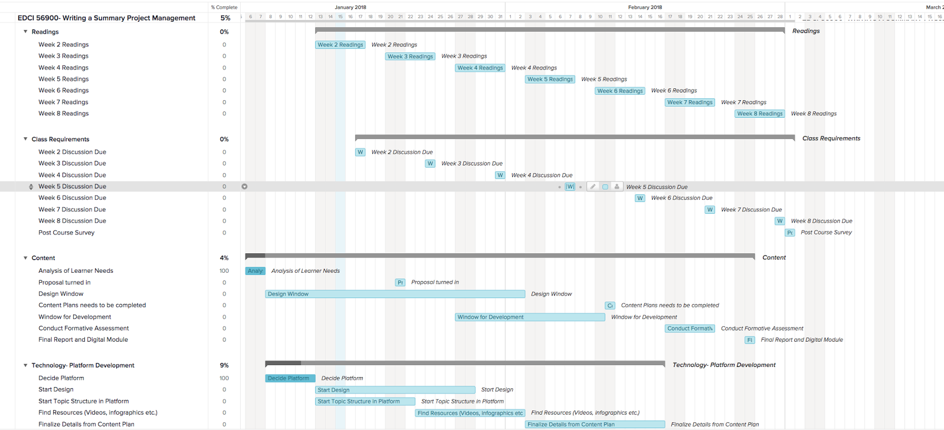

Appendix B:
Activities and Assessment Plan
Activity/Portion of Module | Assessment
(Do) Practice reading and then taking a quiz on Google Forms to choose the best source. | The activity will be made within Google Forms. It will be a quiz and will show students immediate feedback on their answers for Learning Objective #2.
(Do) Practice Proofreading by highlighting the issues and errors in a sample text. | The students will need to find the errors and then color-code them based on if they are a grammar, spelling, capitalization or punctuation error. They will get feedback within Google Classroom.
(Do) Connect Activities: All students will be required to add to their working document. The module gives specific things that need to be added. | Google Comments will be left on the learner’s working document to see if they successfully implemented the requirement for the learning objectives for #1, #3 and #4.
Formative Assessment | Rubric attached to Google Doc using the extension Goobric.

Appendix C:

Site map

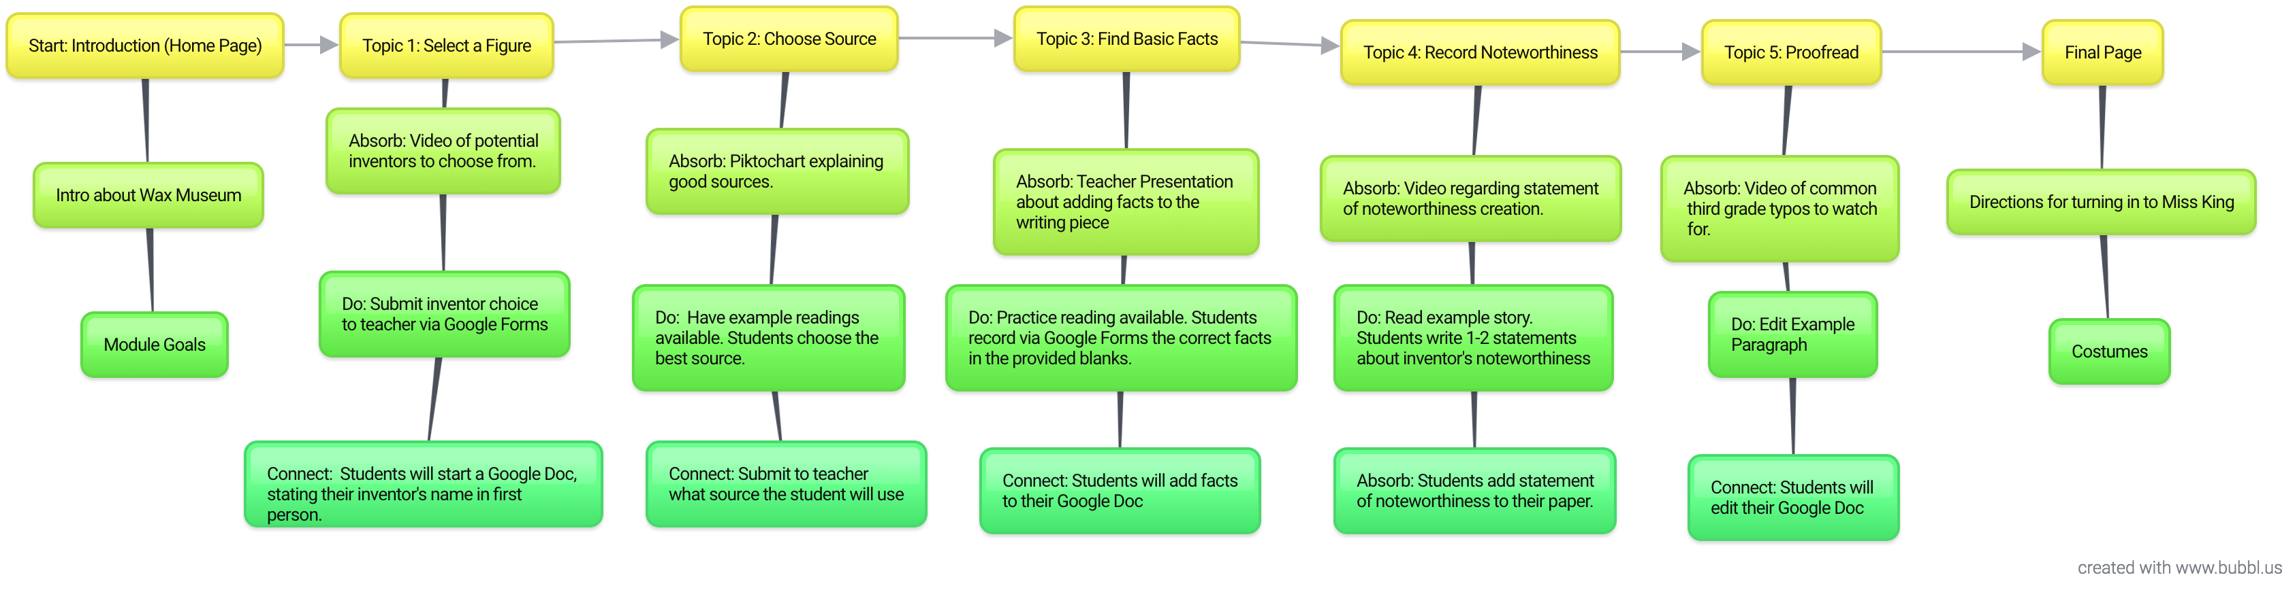

Appendix D:

Wireframe layout

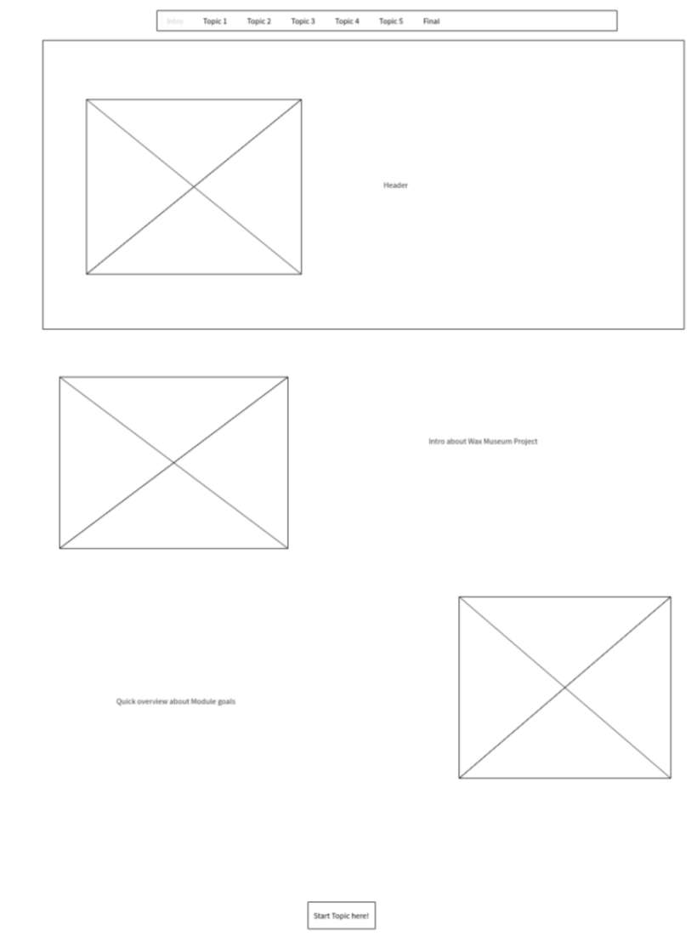
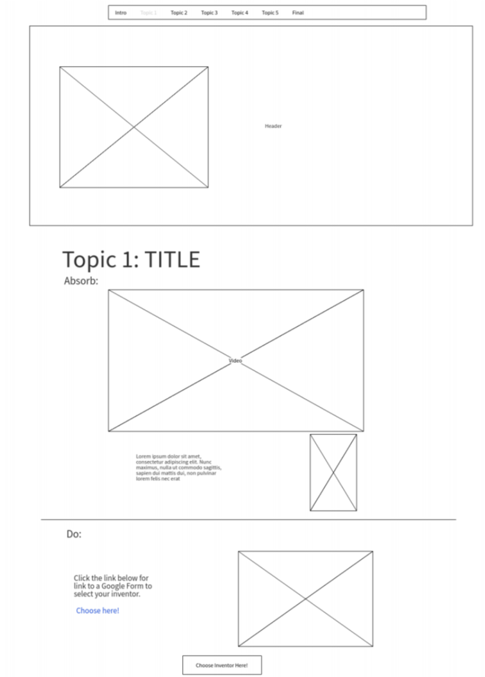
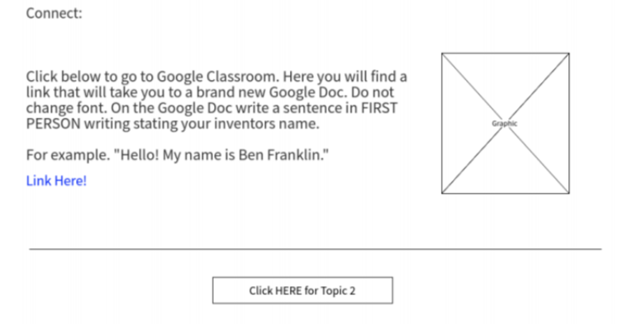

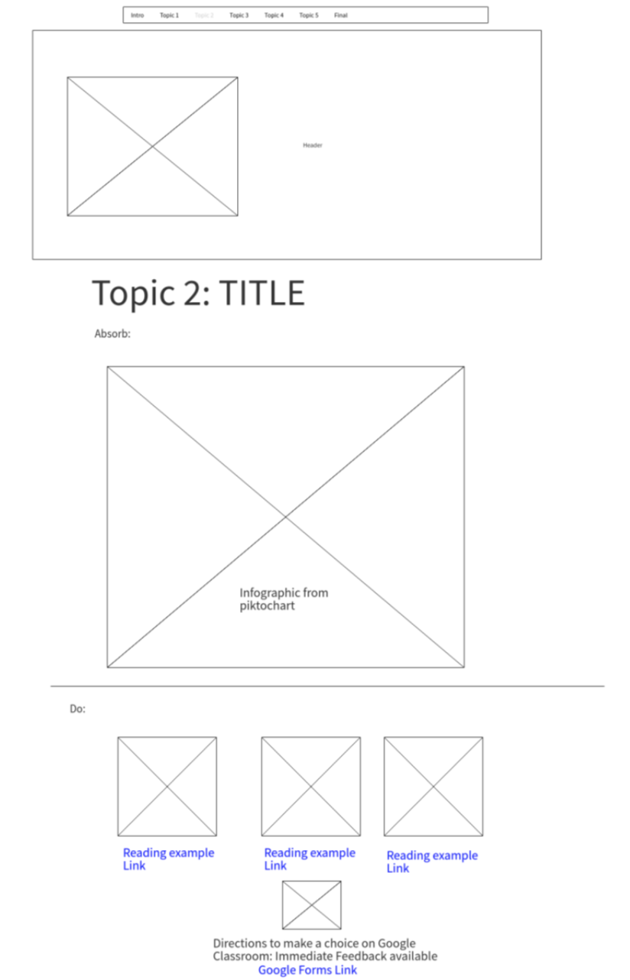
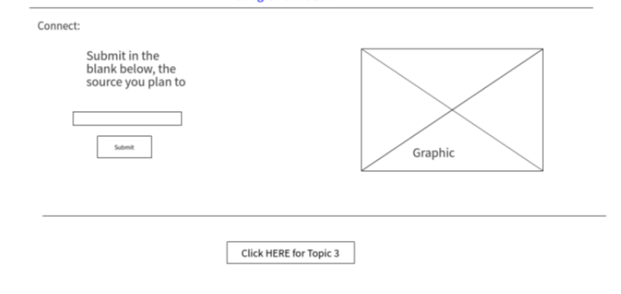

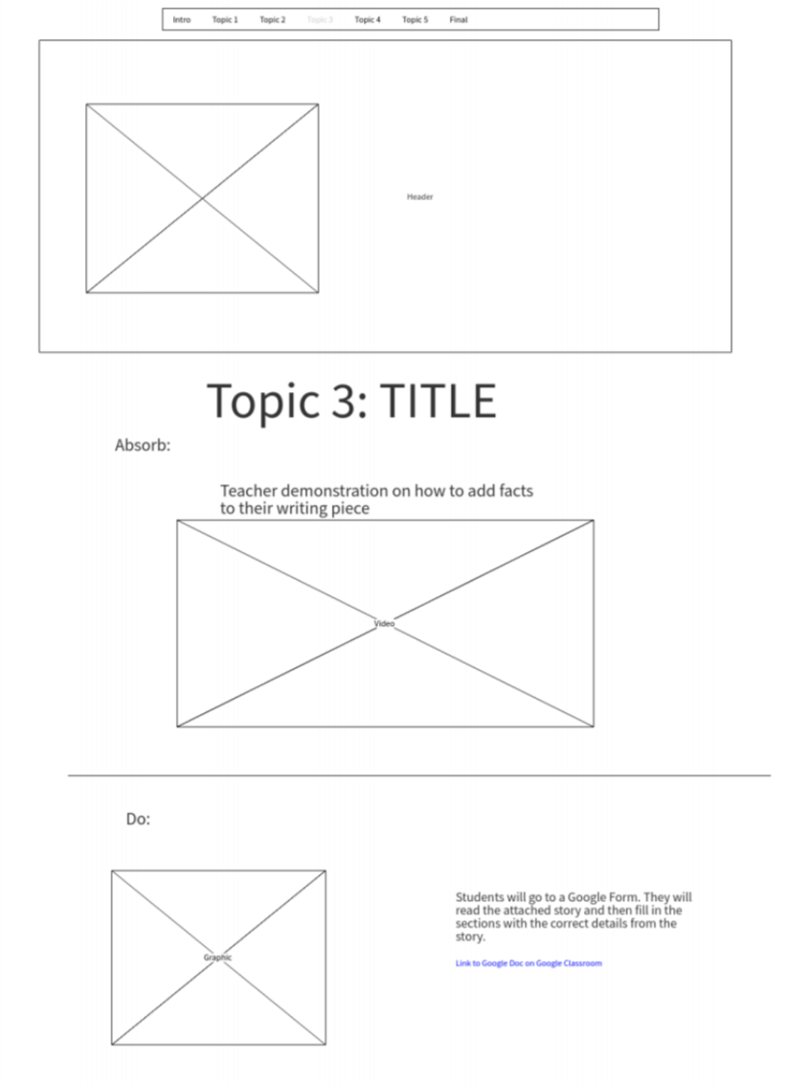
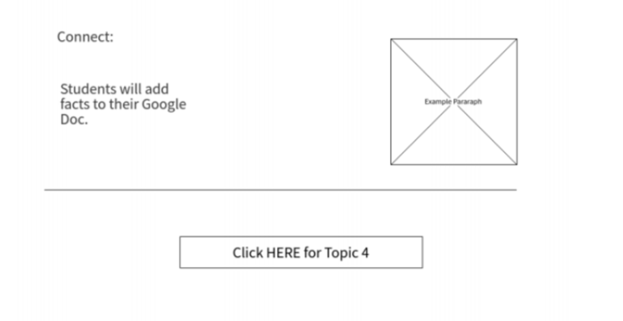
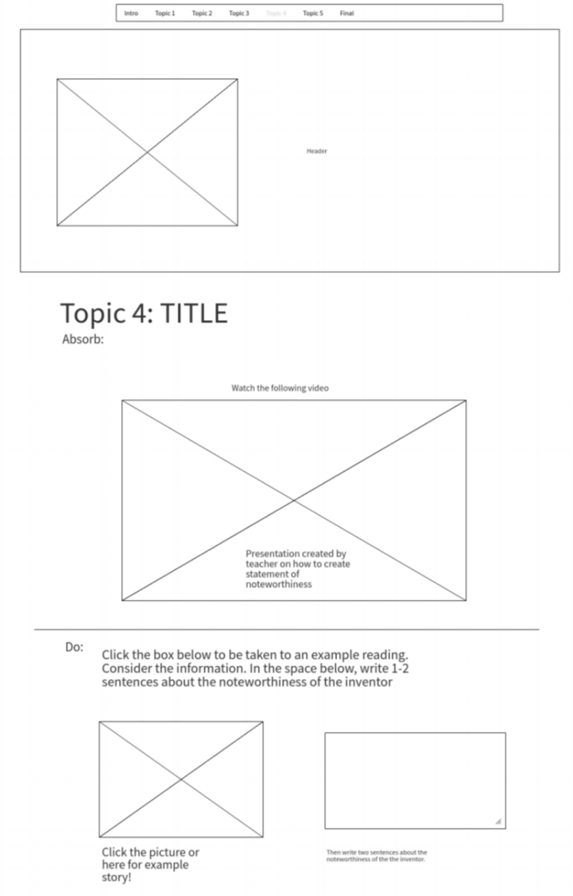
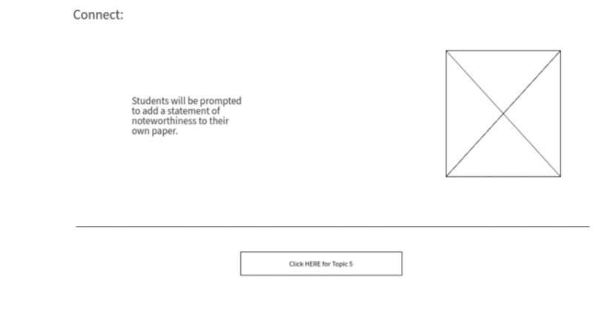

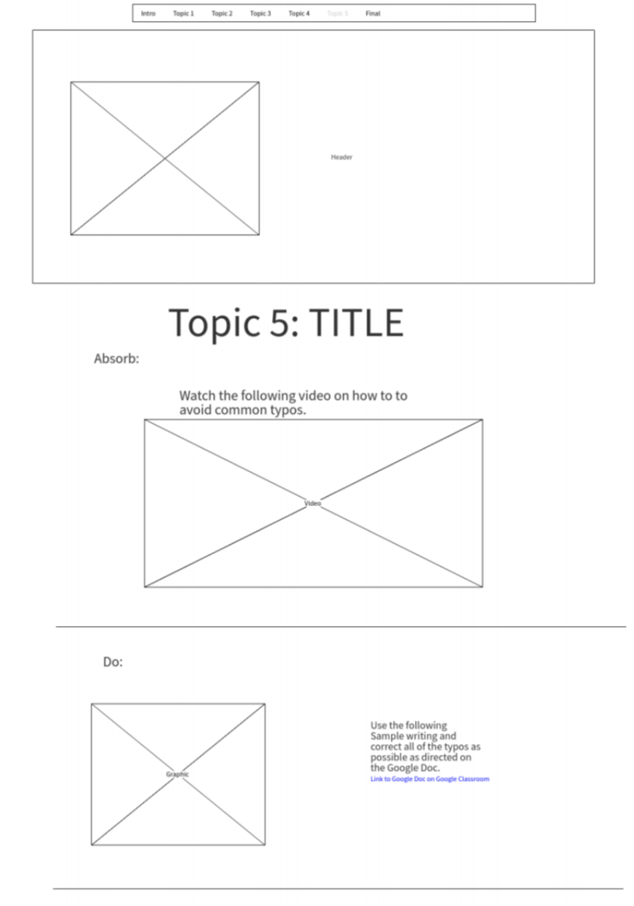

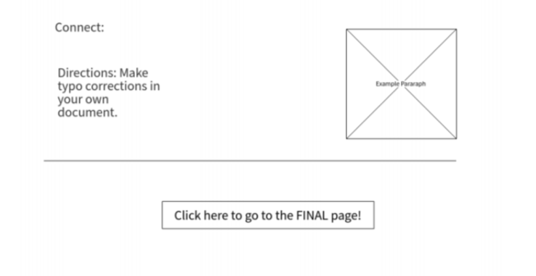
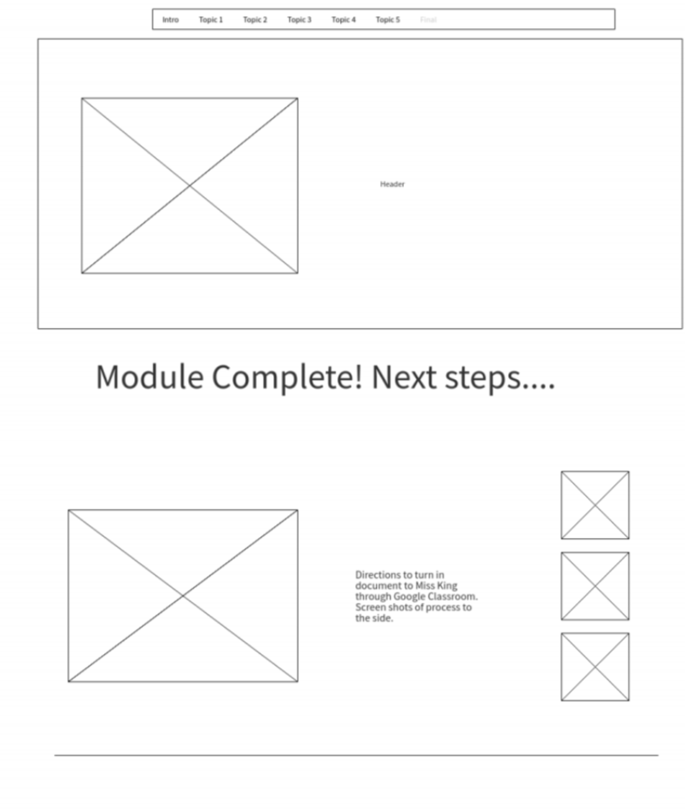
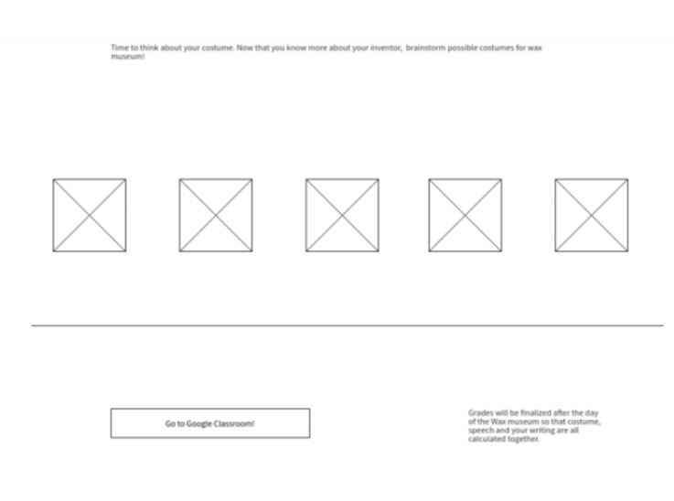

Appendix E:
Complete list of possible inventors to choose from. They are color coded by male and female.

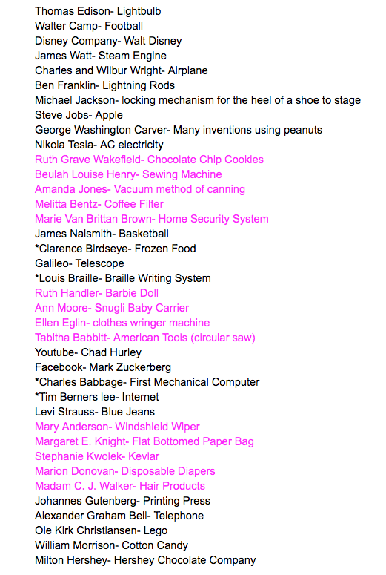

Appendix F:
Topic 1 Do Activity

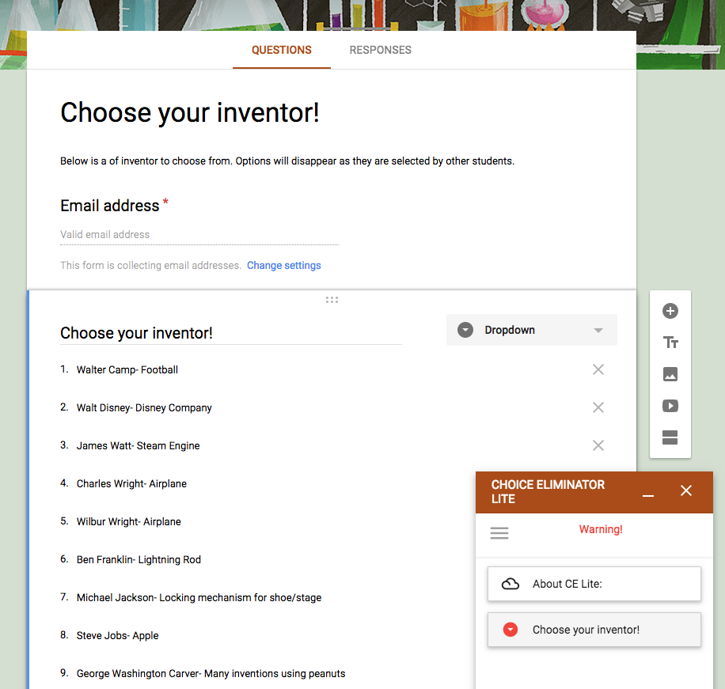

Appendix G:
Google Classroom set up for Topic 1 connect activity.
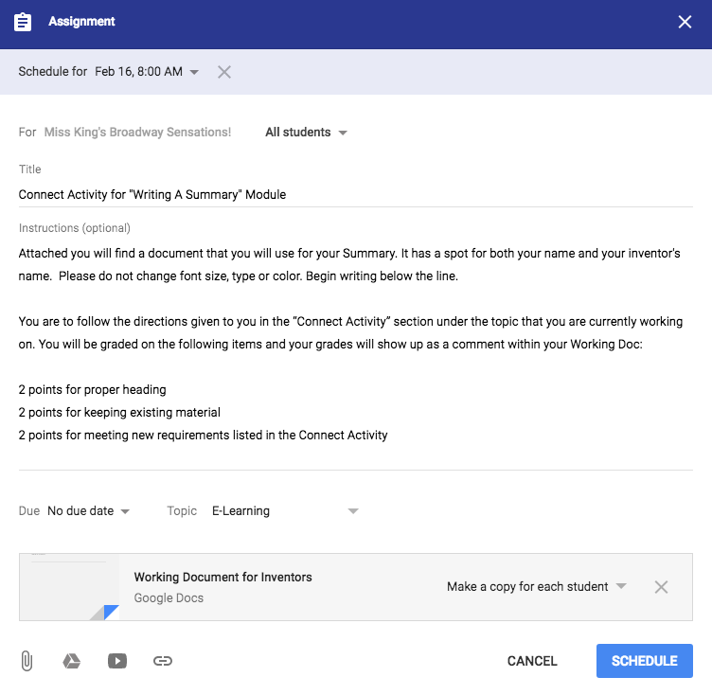

Appendix H:
Topic 2 “Best Source” activity with Answer Key
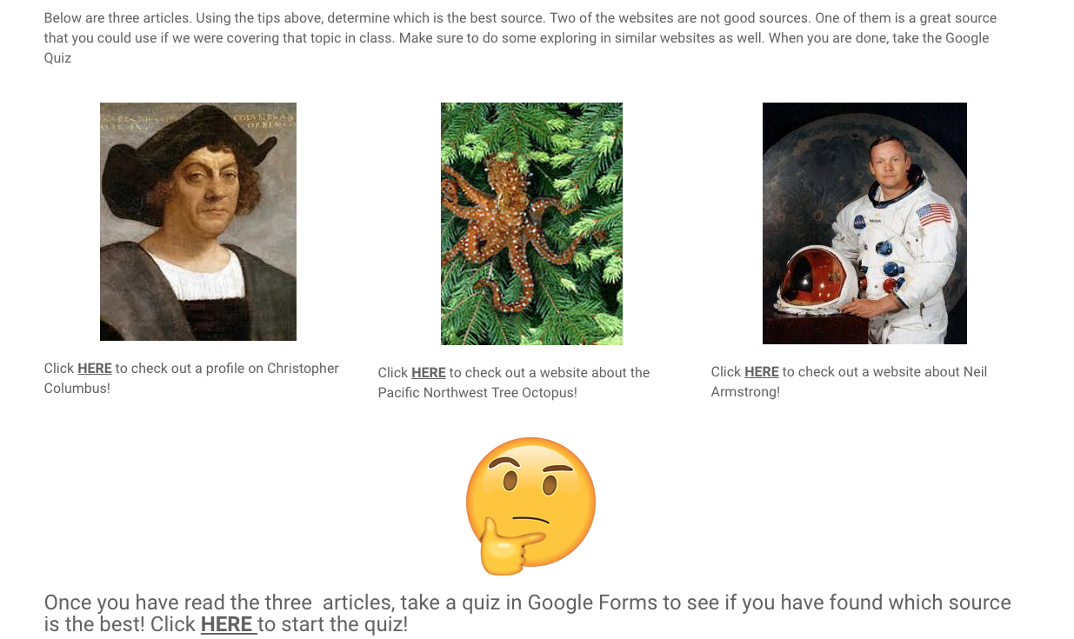
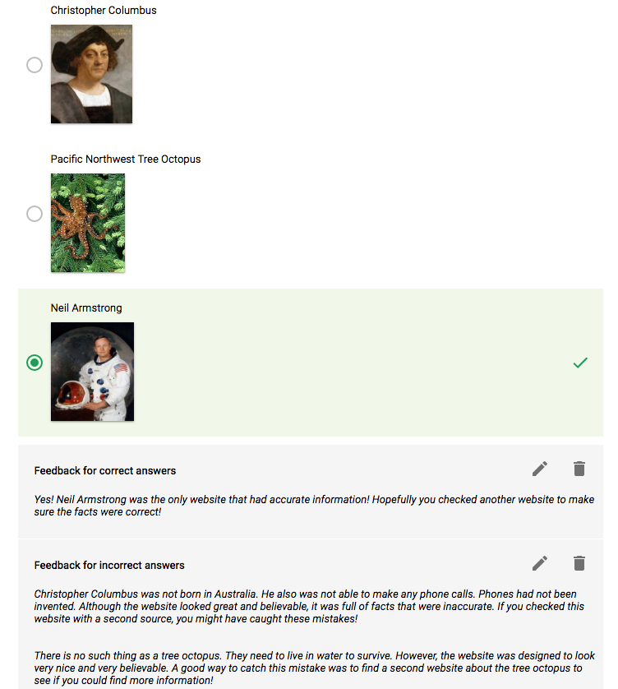

Appendix I:
Source selection connect activity for Topic 2
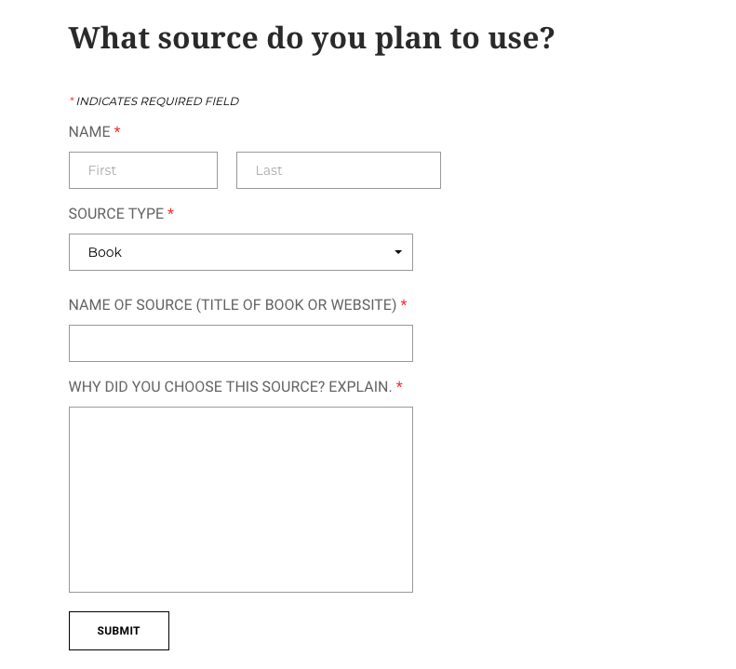

Appendix J:
Topic 3 Do Activity requirements
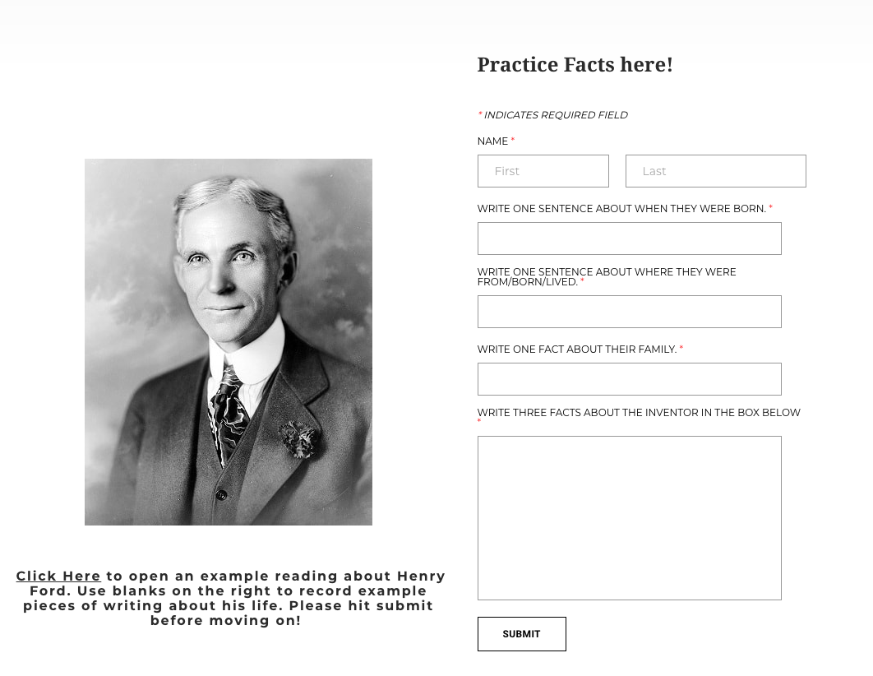

Appendix K:
Google Classroom assignment for the Do Activity in Topic 5.

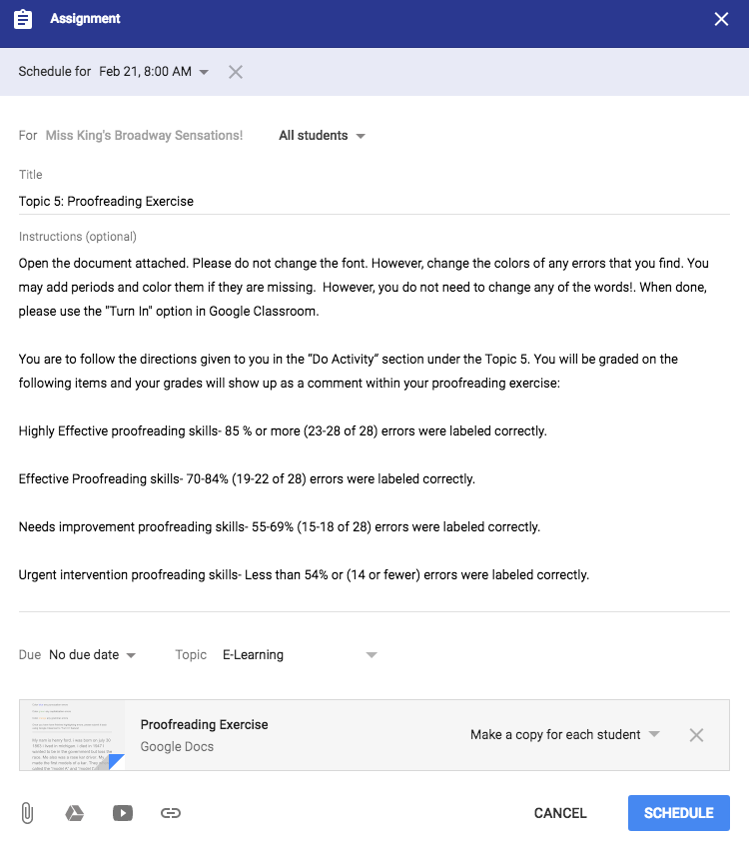

Course Rubric

Points Possible | Criteria / Required Element
No Additional Points  -5 deduction if not included or revised | Analysis Phase  Revised if necessary
5 | Site Directory or Site Map
5 | Storyboard or Wireframe
10 | All Course Content
5 | Self-Evaluation

