Web-Enhanced Lesson: European Vacation Budget Project
Ali King
Purdue University

Driving Question:
Why is a budget needed for an international vacation and how could we create a limited budget for activities that we would like to do in our favorite European country?
Part A and B: Summary
This lesson will be geared towards third grade students from a rural background. There will be 20 students that are split into groups of four. Groups will be determined by the instructor by spreading academic skills, computer skills, and creativity evenly among the groups. The students will have an hour every day during social studies for two weeks to finish this project. This lesson will be taught as part of our international studies unit in which each of the six third grade classrooms take a continent and cover its characteristics during the entirety of May. Our school relies heavily on collaborative tools such as items through the Google's GAFE (Google Apps for Education) suite. These will allow the students to collaborate while planning, however there will also be other tools utilized.
The learners will be introduced to why we use budgets in our lives and then will be creating a budget for the first time. During the project, there will be discussions of similarities of global economies. They will have a set limit of $3,000. Working with a number that is set, will ensure that the students are working with multiple operations using four-digit numbers. This aligns with Indiana third grade College and Career Ready standards.
For this project, I will be utilizing project based learning. I will be acting as a guide and coach for my students. I believe both partnering roles are necessary for different types of students within my classroom. As defined by Prensky (2010), a partnering coach gives a lot of feedback and motivation to their students. Prensky (2010) also defines a partnering guide as slightly different than a coach. He states, “Being a guide, to a much greater degree than being a coach, requires that the students accept they need one and acknowledge that they are willing to take the journey” (p. 60).
Investigations will be scattered throughout this lesson. They will begin be exploring already made budgets. This will act as a point of reference as they build their own budgets. Once the students have been assigned a country and have pinpointed a budget style and tool, the students should then begin investigating different activities or expenses for their budget. This is clearly laid out within the scaffolding in Table 1A. They will also have to do investigations and consider differences in currencies.
Knowledge, Skills and Dispositions
Table 1A
Learning Objectives | Activities | Scaffolds and Tools | Assessments
The students will be able to research websites, collect information such as prices for activities and record them in a simple budget format and present their findings in a mode of their choice. | The students will brainstorm what creating a budget means. The teacher will introduce the project.  Students will have time to work in small groups to plan their budget and then will decide how to split responsibilities of each member of the group. | Tools: Google Chrome. Mentimeter.com, menti.com, ideaboardz  Using mentimeter and menti.com, the students and teacher will make a word cloud to determine what we already know about budgets.  After reviewing our word cloud, the teacher will introduce the project. Students will use Google Chrome to then find examples of budgets they might consider using. Google Chrome will be the tool for all and any research for this project.  The teacher should also allow time for there to be a compare and contrast activity in which the students compare good budgeting and bad budgeting using an ideaboardz designed by the teacher.  The teacher will also list several possible jobs within each group such as leader/fact and math checker, scribe, researcher and computer expert. The students will need to take on a role yet maintain a collaborative workspace and group. Once roles are determined, budget styles are selected and tool of preference chosen, they may begin exploring possible expenses for their budget. | Formative Assessment: The teacher will be conducting ongoing quick checks to make sure the students are not having any issues. There will be a checklist available to help the teacher decide if progress is being made in this area (See Appendix A).  Summative Assessment: If the students can access information from the web and document the information, it will be considered as meeting their goal. This will be one part of their overall rubric. (See Appendix B).
Students will be able to present their student-created budgets for a European vacation using the web 2.0 tool of their choice after being informed of a budget’s use and importance in everyday life. | There will be about 10 minutes for the educator to inform the class about possible tools towards the beginning of the project. Students will design their projects within the two weeks, and then they will be given up to 10 minutes to present their projects at the end of the project allotment time (2 weeks).  Students will also be asked to demonstrate their knowledge of good budgeting habits and characteristics versus bad using Ideaboardz to compare and contrast. | Tools: YouTube, Google Slides, Padlet, Glogster, Ideaboardz  The teacher will do a brief (5 minute) rundown of YouTube, Padlet and Glogster to demonstrate possible tools to use for the students to display their final budget. The teacher should encourage the students to explore unfamiliar functions of these tools themselves and not rely on a lecture to learn the use of a certain tool.  The teacher will also show examples of budgets using Glogster, YouTube and Padlet. We will also begin pinpointing what type of areas we need to include in our budget. The teacher will suggest the following categories at a minimum: food, activities, lodging and airfare, souvenirs, emergency and transportation.  The five groups will be given 10 minutes to present the highlights of their budget in front of the class. The classroom believes in the importance of publishing and sharing our work as well. The budgets will be available at the International Festival during the last week of school. | Formative Assessment: There will be a reflection piece (Appendix C) to determine the students’ understanding of the purpose of a budget. It will be assessed but not a grade for the student. Another formative assessment will be the ideaboardz comparing good and bad budgets (See Appendix F).  Summative Assessment: I will have a piece in my overall rubric (Appendix B) to assess their use of Padlet, youtube, glogster or the tool of their choice. This rubric will also be the summative assessment to assess their choice of tool and use of the tools and content of their project. This will count as a grade in social studies.
Students will be able to compare, using ideaboardz, basic information regarding global economies as well as become more of a global and financially responsible group of citizens in the process. | Students will have time to gather facts and discuss economies during the beginning of the lesson. After quick discussions, students will be guided to use Padlet or ideaboardz to sort their ideas. Teacher will give further support and instruction on how to complete the ideaboardz project. This will be a one day activity, but will be referenced throughout the course of the project | Tools: Padlet, http://ideaboardz.com/, YouTube  The teacher will share a video from a YouTube channel called "Crash Course" that will be an introductory to economics. The teacher will ask them a series of questions that will help them form opinions and ideas as to what their part in a European economy might be, which of course is a tourist. We will talk about the differences between a tax-payer and a tourist.  The teacher will then generate an ideaboardz and let the students compare our economy with a European economy. They will be allowed to research facts for their ideaboardz. There should be a time provided by the teacher to do a follow up discussion to talk about the comparisons. | The ideaboardz activity will be the formative assessment that I use to determine their knowledge of other economies and budget (See Appendix G). There will not be a summative assessment. This objective needs to be addressed and informally assessed, but is not a primary goal of this lesson.
Students will be able to collaborate in small group settings in addition to having roles within each group. | This will be an ongoing activity. Whether they are planning their final product, collecting information, or working on several other components of the project, they will be collaborating from start to finish. | Tools: Google Products (Docs, sheets, and slides can have multiple people working on a document at the same time), Padlet, Glogster  There will be a rubric provided to the students of expectations for their collaborative group work. This will push the students to cooperate with their peers at the highest level to ensure a well-working atmosphere for all students instead of guessing at what is appropriate behavior.  All tools provided for this project, apart from YouTube, can have multiple authors and be accessed simultaneously. Even though there is only one scribe, the researcher, computer expert and leader can all utilize the collaborative features of these tools. | Summative Assessment: There will be a rubric for the students to assess the work of their partners (Appendix D, bottom) after the unit. They will also have a chance to rate their own participation (Appendix D, top). At this age the teacher must monitor their responses and weigh in on the self-assessment piece.  Formative Assessment: Teachers will have an informal checklist (Appendix E) to use when assessing students’ involvement in their groups. This should be used once a day. Documenting within certain categories will demonstrate the reoccurrence of positive or negative behavior during group work. The teacher will also have an area to make comments on students’ self-assessment sheet (Appendix D).
How will you monitor student learning during the lesson/unit or training?
There are formative and summative assessments that will take place during the two-week lesson that will help the teacher understand the students growing knowledge. Ongoing checklists will also be essential. The key is to also hold informal meetings with students and return feedback as quick as possible to ensure student growth.
What evidence/artifacts will your student produce to demonstrate the desired learning?
The students will be applying their knowledge of a budget using the web 2.0 tool of their choice. This will be an artifact that will be difficult to complete if they do not understand the purpose of a budget. Meeting with the students regularly will eliminate any ongoing stumbling points. They will also be creating an ideaboardz using ideaboardz.com to show their understanding of global economies.
How will you assess students' processes and products (e.g., rubrics, checklists, presentations, exams)? Provide samples of the assessment measures you will use.
See Appendixes A-G
When and by whom will the assessments occur?
Some Assessments will be ongoing as shown by Table 1A earlier in the lesson. Some assessments will be finalized after the conclusion of the project and presentations have been made. The teacher will primarily be responsible for assessing student growth. However, there is an opportunity for students to also self-assess their collaboration skills.
References
Prensky, M. (2010). Teaching digital natives: partnering for real learning. Thousand Oaks, CA: Corwin.

Appendix A

Internet/Web-searching progress monitoring sheet
Name: ____________________ Date: _____________
Please rate a student’s web-searching capabilities based on the criteria below using a 1 through 5 rating scale, 5 meaning “Efficient” and 1 meaning “Needs improvement”.
___ Students can search topics using Google.com within their Chrome browser.
___Students can open links to websites.
___ Students can document information found during a web search electronically or paper.
___Students can use navigational arrows to go to a previous page or forward.
___ Students can make decisions on if a website can be trusted and if the information is useful.

Appendix B
Name: ____________________ Date: _____________
The following chart will be used to assess the overall project: European Budget Project. Please consider the following when putting together your budget.
Goals and Objectives | 1  Needs Improvement | 2  Developing Skill | 3  Efficient | 4  Exemplary (Bonus)
Choice of web 2.0 tool and use for project. | Did not us a tool suggested or approved by a teacher. | Used an approved tool, but did not present content in a functional way (hard to read/follow) | Used an approved tool and used the tool’s features to make a presentable project! | When over and beyond! Used an approved tool and used it to the tool’s fullest potential!
Content of project  (Point value worth x2) | The project is missing 3 or more items from the “Efficient” section.  (2 point value) | The project is missing 2 or more items from the “Efficient” section.  (4 point value) | The project has presented the following material.  1. Lists name of Country  2. Has 10 activities listed in budget including at least a hotel for three nights and roundtrip plane tickets.  3. List amounts of all items.  4. Includes starting money and ending money  (6 point value) | The students met all the requirements of “3” and added more content than required, creating a rich project!  (8 point value)
Research capabilities | Students had many errors regarding information and/or did not actively research information during the project. | Students showed growth during research activities. There may be some errors in researched information. | Student found useful websites and could collect accurate data for their project. | Students found many useful websites and could collect data as well as document where they found their information by listing websites.
Collaboration skills | Student was disruptive. They often hindered the progress of the project. | The student worked, but was hesitant to work with others. | The student worked well with all classmates and kept the project moving. | The student often attempted to lead the group and reached out to many team members to encourage them.
Understanding of a purpose of a budget (as demonstrated by the Budget summative assessment piece). | Student does not demonstrate any knowledge of the purpose of a budget. (Scored 59% or less) | Student shows basic understanding of a budget. (Scored 60% to 80%) | Student understands the purpose of a budget. (Scored 80% to 100%) | Student has accurately applied budgeting concepts to their project and is shown by little to no waste in their activity choice. (Must have also scored 100% to attain bonus)
Total of 18 points possible with a possibility of up to 24 bonus points.

Total points ______
Comments:

Appendix C
Name: ____________________ Date: _____________
Please answer the following questions regarding the use of a budget.
1. What is the purpose of a budget?: _______________________________________________________________________________________________________________________________________________________________________________________________________________________________________________________________
2. True or False? Income is money that we received from a job or allowance?
______________
3. What is the best definition for “expenses”?
A. Money we have saved.
B. Money we have or will be spent on goods or services.
C. Things that cost a lot of money.
D. Money that we get for doing a job
4. Budgets can only be used by adults. True or False? ______________
5. Miss King budgeted $50 for candy for the week. Is this reasonable? Why or Why not?___________________________________________________________________________________________________________________________________________________________________________________________________________________________________________________________
6. Please list three good categories for a personal budget:
____________________ ________________________ ___________________
7. Joseph planned a budget inside of a notebook he always keeps in his room. Is this a good place for a budget? Why or Why not?______________________________________________________________________________________________________________________________________________________________________
8. Where else could Joseph record/plan a budget? ___________________________________
9. What are goods?____________________________________________________
10. What are services?__________________________________________________

Appendix D

Name: ____________________ Date: _____________
The following chart will be used to assess collaboration skills. Inside the rubric the teacher may write comments or mark the appropriate column.
Goal/Objective | Still Learning (1 point) | Sometimes (2 points) | Almost Always (3 points)
I respect my classmates
I do my job/work without being told
I listen to my classmate’s ideas
I share ideas with my classmates
I help my classmates when possible.

The hardest working student in my group: ____________________
Who had the best ideas: _________________
Did you feel there were problems working with some members of your group? Yes or NO. ______
What was the easiest part of this assignment (or so far)? _______________________________________________________________________________________________________________________________________________________________________________________________________________________________________________________________________________________

What was the hardest part of this assignment (or so far)?
_______________________________________________________________________________________________________________________________________________________________________________________________________________________________________________________________________________________

Comments:

Appendix E

Name: ____________________ Date: _____________
The following chart will be used to assess collaboration skills. Inside the rubric the teacher may write comments or mark the appropriate column. Teacher may also reuse sheet by utilizing dates within each box.

***Teacher Checklist**
Goal/Objective | Still Learning (1 point) | Sometimes (2 points) | Almost Always (3 points)
Student is showing respect to other students
Student is doing their job to the best of their ability
Student is listening to other classmates
Student is sharing ideas with classmates
Student is helping team whenever possible
Additional Comments:

Appendix F
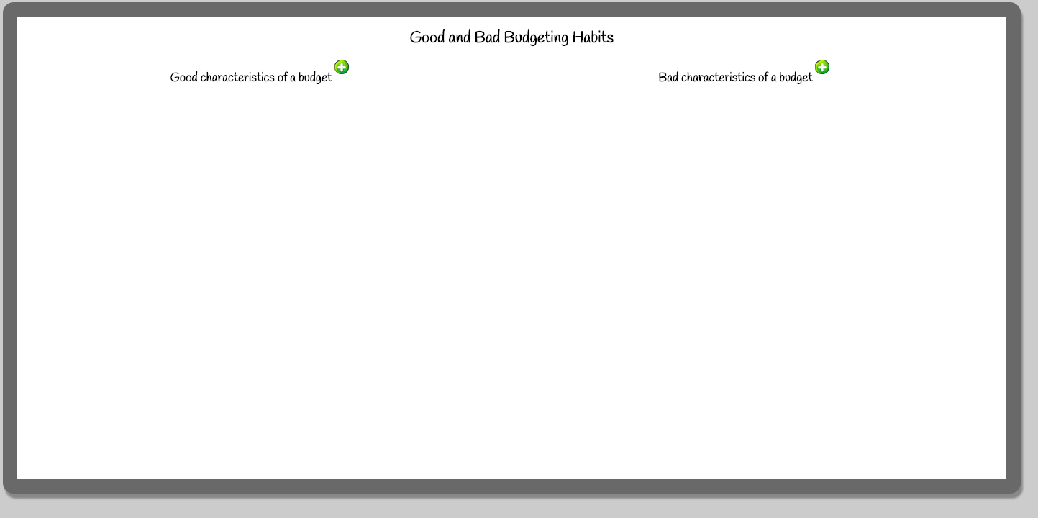

Appendix G